POTENTIAL CONFLICT OF INTERESTS DISCLOSURE FORM

The participants in a continuing medical education (CME) or continuing professional development (CPD) activity should know in advance of any affiliation or financial interest that could influence the presentation of a speaker, a workshop leader or a resource person. The intention of disclosure is not to prevent a presenter with a potential conflict of interests from speaking, but to inform the audience in advance of the possible affiliations or financial interests. Since these facts are known openly, the participants can render an informed judgement on the content of the presentation itself.

Affiliation means, for example, acting as an advisory board member for a pharmaceutical company; financial interest means, for example, accepting an invitation, gratuity or remuneration for services rendered, royalties or research funds from a business corporation, or holding a financial interest in an enterprise.

Declaration of the resource person (speaker, facilitator, scientific committee member or others)

I currently have, or I have had in the past two years, an affiliation with/or financial interest of any nature in a business corporation, or I receive remuneration, royalties or research grants from a business corporation :
no yes

If yes, specify the type of affiliation (for example : I am an advisor for the XYZ company, I have been invited recently bv the XYZ company, I have been speaker for company XYZ, I am receiving research funds from the XYZ company, I am holding shares in actions the XYZ company, etc.), the name(s) of the business corporation(s) (pharmaceutical or other) and the period covered by the affiliation.

Type of affiliation | Name of the corporation | Period
PI, Medical Advisory Board | Allergan | 2014-present
PI | Afferent Pharmaceuticals | 2014-present
PI, Medical Advisory Board | Urigen Pharmaceuticals | 2014-present
Medical Advisory Board | Aquinox Pharmaceuticals | 2015-present
Medical Advisory Board | Tribute Pharmaceuticals | 2015-present

name (block letters) : ROBERT M MOLDWIN, MD __________________________________________________

Title and date of educational activity : #23 A Phase 2 Study in Women with Interstitial Cystitis/Bladder Pain Syndrome (IC/BPS) of the Novel P2X3 Antagonist AF-219 , OCTOBER 7, 2015

_________________________________________________________________________________

Signature 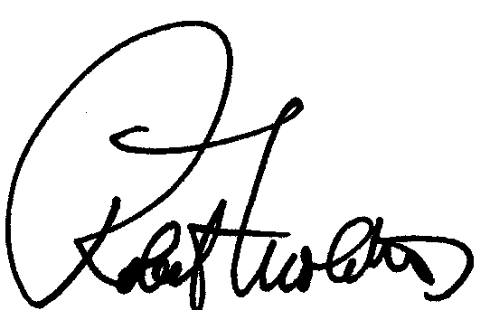 Date: July 15, 2015

Responsibility of the organizer

It is the responsibility of the organizer of an educational activity to have this form completed by each resource person : speakers, facilitators, scientific committee members or others. The organizer shall ensure that the information is made available to the participants by a notation in the course syllabus and that potential conflicts of interests (or the absence thereof) are disclosed by the presenter at the beginning of his presentation (oral and visual disclosure with slide).

For the sake of equity and transparency, the organizer will inform the participants that :
- The resource person did not declared any potential conflict of interests;
- The resource person declared a potential conflict of interests (in this case, the nature of the conflict will be described as mentioned by the resource person); or
- The resource person did not return the potential conflict of interests disclosure form.

