AN INTERNATIONAL CONTINENCE SOCIETY (ICS)
REPORT ON THE TERMINOLOGY
FOR MALE ANORECTAL DYSFUNCTION – VERSION 15
Alexis Schizas*, Alison Hainsworth#, Andreia Albuquerque, Bernard Haylen*, Hege Holmo Johannessen, Paula Igualada-Martinez, Eugene Ong, Giulio Santoro, Arvid Stordahl,
# AS and AH are equal first authors (Production and Content),

Standardization Steering Committees ICS*, ICS Working Group on
Terminology for Male anorectal dysfunction
Alexis Schizas: Guy’s and St Thomas’ Hospitals, London. UK, aschizas@doctors.net
Alison Hainsworth: Guy’s and St Thomas’ Hospitals, London UK, allyhainsworth@googlemail.com
Andreia Albuquerque: University of Porto, Porto. Portugal, a.albuquerque.dias@gmail.com
Bernard Haylen: University of New South Wales, Sydney. Australia. bernard@haylen.co
Hege Holmo Johannessen: Ostfold Hospital Trust and Ostfold University College, Ostfold. Norway, hege.h.johannessen@hiof.no
Paula Igualada-Martinez: Guy’s and St Thomas’ Hospitals, London. UK, pigualadamartinez@gmail.com
Eugene Ong: St Vincents Hospital, Melbourne. Australia, ejskong@gmail.com
Giulio Santoro: Treviso Regional Hospital, Treviso. Italy, giulioasantoro@yahoo.com
Arvid Stordahl: Ostfold Hospital Trust, Ostfold. Norway, arvid.stordahl@online.no

Correspondence to: Alexis Schizas MRCS FRCS MD, Colorectal Surgery, 11th floor, North Wing, St Thomas’ Hospital, Westminster Bridge Road, London, SE1 7EH, United Kingdom
Tel: 00447793752188 Email: ampschizas@gmail.com
ABSTRACT:
Introduction: The terminology for anorectal dysfunction in men has long needed a specific clinically-based Consensus Report.

Methods: This Report combines the input of a Working Group of members of the International Continence Society (ICS), assisted at intervals by external referees. Appropriate core clinical categories and a sub-classification were developed to give a coding to definitions.
An extensive process of 15 rounds of internal and external review was involved to examine each definition, with decision-making by collective opinion (consensus).

Results: A Terminology Report for male anorectal dysfunction, encompassing separate definitions, has been developed. It is clinically-based with the most common diagnoses defined. Clarity and user-friendliness have been key aims to make it interpretable by practitioners and trainees in all the different specialty groups involved in male anorectal dysfunction. Male-specific imaging (ultrasound, radiology and MRI) and conservative and surgical managements are major additions and appropriate figures have been included to supplement and clarify the text. Emerging concepts and measurements, in use in the literature and offering further research potential, but requiring further validation, have been included as an appendix. Interval (5-10 year) review is anticipated to keep the document updated and as widely acceptable as possible.

Conclusion: A consensus-based Terminology Report for male anorectal dysfunction has been produced to aid clinical practice and research.

DISCLOSURES:
Alexis Schizas: No disclosures.
Alison Hainsworth: No disclosures.
Andreia Albuquerque: No disclosures.
Bernard Haylen: No disclosures.
Hege Holmo Johannessen: No disclosures.
Paula Igualada-Martinez: No disclosures.
Eugene Ong: No disclosures.
Giulio Santoro: No disclosures.
Arvid Stordahl: No disclosures.

WORDS: ABSTRACT: 212 words; TEXT: Introduction to Section 6: 9173 words
FIGURES: 7
TABLES: 1
INTRODUCTION
Anorectal dysfunction comprises a group of abnormalities as a result of a change in the normal function of the pelvic floor, anal canal and rectum. This can be due to anatomical (e.g. rectocoele, anal sphincter injury) or functional (e.g. anismus) abnormalities. The anatomical configuration of the anorectum is complex. The mechanisms that control continence and allow defaecation are multifactorial and dependent on many factors such as the consistency of stool, bowel transit, rectal compliance and sensitivity, intact neurological function and integrity of the pelvic floor, and anal sphincters.
There is currently no single document that encompasses all elements required for diagnoses in male anorectal dysfunction that includes a full outline of the terminology for symptoms, clinical examination signs, and diagnostic investigations. The International Continence Society (ICS) has provided leadership in terminology for female anorectal dysfunction and male lower urinary tract dysfunction over decades employing combined or generic reports (1–5). This document aims to standardise the elements for male anorectal dysfunction and will include aetiology, classification, and terminology for the different investigation modalities.
The investigations described aim to define both the anatomy and the function of the anorectum and pelvic floor. Anorectal physiology focuses primarily on functional aspects and dynamic imaging, such as defaecatory imaging or transperineal ultrasound, also give information about the way in which the anorectum is working. Other imaging, such as endoanal ultrasound and static MRI, show the anatomy of the anorectum, pelvic floor and pelvic organs.
The core references are from the relevant core terminology documents and will be references:
- 2010 IUGA-ICS Joint Terminology Report on Female Pelvic Floor Dysfunction (1),
- 2017 IUGA-ICS Joint Terminology Report on Female Anorectal Dysfunction (2),
- the equivalent 2019 Male Terminology for Lower Urinary Tract and Pelvic Floor Dysfunction (with its greatly expanded range of definitions) (3).
- the 2016 IUGA-ICS Joint Terminology Report on Pelvic Organ Prolapse (4) and the World Health Organization’s fistula publication (6).
- the terminology document for terminology in chronic pelvic pain syndromes (7).
- An original aim of the IUGA-ICS Joint Terminology reports has been to provide a general terminology, forming the “core” terminology to which more specific terminologies can be attached. Reference can also be made to other published Standardization Reports (5,8,9) and 6 joint IUGA-ICS Female Terminology Reports (2,4,10–13).
This Terminology Report is inherently and appropriately a definitional document, collating the definitions of those terms, i.e. “words used to express a defined concept in a particular branch of study”, here anorectal dysfunction. Emphasis has been on comprehensively including those terms in current use in the relevant peer-reviewed literature. The aim is to assist clinical practice and research. Explanatory notes on definitions have been referred, where possible, to the “Footnotes” section. The appendices are used to supplement the definitions in this document. The main document concentrates primarily as definitions, with techniques, values and scoring systems in the appendix.
Like all the other ICS terminology reports, every effort has been made to ensure this Report is:
(1) User-friendly: It should be able to be understood by all clinical and research users.
(2) Clinically-based: Symptoms, signs and validated assessments/investigations should be presented for use in forming workable diagnoses for male anorectal dysfunctions.
(3) Origin: Where a term’s existing definition (from one of multiple sources used) is deemed appropriate, that definition will be included and duly referenced.
(4) Able to provide explanations: Where a specific explanation is deemed appropriate to describe a change from earlier definitions or to qualify the current definition, this will be included as an addendum to this paper. Wherever possible, evidence-based medical principles will be followed.
It is suggested that acknowledgement of these standards in written publications related to male anorectal dysfunction, be indicated by a footnote to the section “Methods and Materials” or its equivalent, to read as follows: “Methods, definitions and units conform to the standards recommended by the International Continence Society except where specifically noted.

TABLE 1: Total, new and changed definitions (compared with previous male-inclusive Reports^{1,2}).
Section | Unchanged Definitions / Descriptors | New Definitions / Descriptors | Changed Definitions / Descriptors | Total
Symptoms | 28 | 12 | 5 | 45
Signs | 5 | 33 | 6 | 44
Assessment tools and questionnaires (non invasive) | 2 | 14 | 1 | 17
Anorectal Physiological Investigations | 6 | 14 | 9 | 29
Anorectal Imaging | 7 | 9 | 9 | 25
Diagnoses | 3 | 7 | 1 | 11
Total | 51 | 89 | 31 | 171

SECTION 1: SYMPTOMS
Symptom: Any morbid phenomenon or departure from the normal in structure, function or sensation, experienced by the man and possibly indicative of disease or a health problem. Symptoms are either volunteered by, or elicited from, the man or may be described by the man’s partner or caregiver (1,2).
1.1 Incontinence
1.1.1 Anal Incontinence: The complaint of involuntary loss of flatus or faeces (1);
1.1.2 Faecal incontinence: Complaint of involuntary loss of faeces - when faeces is solid and/or - when faeces is liquid (1).
1.1.3 Flatal Incontinence: Complaint of involuntary loss of flatus (gas) (1).
1.1.4 Double incontinence: Complaint of both anal incontinence and urinary incontinence (2).
1.1.5 Passive faecal leakage: Involuntary soiling of liquid or solid stool without sensation or warning, or difficulty wiping clean (2).
1.1.6 Overflow faecal incontinence: Complaint of involuntary loss of stool due to an overfull rectum or faecal impaction (2).
1.2 Anorectal storage symptoms
1.2.1 Increased daytime defaecation: Complaint that defaecation occurs more frequently during waking hours than previously deemed normal by the man (2).
1.2.2 Nocturnal defaecation: Complaint of interruption of sleep one or more times because of the need to defaecate (2).
1.2.3 Faecal (rectal) urgency: Complaint of a sudden compelling desire to defaecate that is difficult to defer. (Faecal urgency warning time: time from first sensation of urgency to voluntary defaecation or faecal incontinence) (1).
1.2.4 Faecal (flatal) urgency incontinence: Complaint of involuntary loss of faeces or flatus associated with faecal or flatal urgency (1). CHANGED
1.2.5 Tenesmus: Complaint of the continual or recurrent desire to evacuate the bowel accompanied by involuntary straining and spasm but the passage of little faecal matter(3) There may be an associated abdominal or perineal pain at the time of defaecation. CHANGED
1.3 Anorectal sensory symptoms
1.3.1 Diminished rectal sensation: Complaint of diminished or absent sensation in the rectum (1).
1.3.2 Increased rectal sensation: Complaint of a desire to defaecate that occurs earlier or more persistent to that previously experienced (1).
1.4 Defaecatory symptoms and techniques
1.4.1 Constipation: Complaint that the bowel movements are infrequent and/or incomplete and/or there is a need for frequent straining or manual assistance to defaecate (Rome IV criteria (1–3).
1.4.1.1 Slow transit: Infrequent and/or hard bowel motions due to a delay in transit of bowel contents to reach the rectum.
1.4.1.2 Obstructed defaecation: Complaint of incomplete evacuation of faecal contents from rectum due to physical or functional blockage, preventing evacuation of the faecal stream during defaecation attempts. CHANGED
1.4.2 Defaecatory difficulty: Complaint of difficulty in evacuation, would include obstructive defaecation and constipation (2) and functional bowel disorders. NEW
1.4.3 Straining to defaecate: Complaint of the need to make an intensive effort (abdominal straining or Valsalva) or to use abdominal massage to either initiate, maintain, or improve defaecation (1,3).
1.4.4 Rectal digitation: Use of fingers in the rectum to manually assist in the evacuation of stool contents (2,3).
1.4.5 Splinting: Support perineum or buttocks manually (usually with thumb or fingers) to assist evacuation of stool contents (2).
1.5 Post defaecatory symptoms
1.5.1 Incomplete bowel evacuation: Complaint of stool remaining in the rectum after defaecation and may be accompanied by the desire to defaecate again. NEW
1.5.2 Post defaecatory soiling: Complaint of soiling occurring after defaecation (2,3).
1.5.3 Anorectal prolapse: Complaint of external protrusion, “bulge” or “something coming down”, towards or through the anus/rectum. The man may either feel the bulge by direct palpation or see it with a mirror (2) (examination is required to differentiate between rectal mucosal prolapse and full thickness rectal wall prolapse (muscle and serosal layers)) (3). CHANGED
1.6 Pain _{FN 1.1 and 1.2}
1.6.1 Anal Pain: Complaint of pain, pressure or discomfort in the anus. Occurs particularly during defaecation or straining to defaecate but can occur at any time. NEW
1.6.2 Proctalgia: Complaint of pain perceived by the patient to be located to, or arising from, the rectum. NEW
1.6.2.1 Proctalgia fugax: Severe recurrent episodic pain localised in the anus or lower rectum which lasts seconds to minutes; there is no pain between episodes (7). NEW
1.6.2.2 Chronic proctalgia: rectal pain, more than 20 minutes of duration per episode with symptom onset of at least 6 months prior to diagnosis (7). (There is persistent or recurrent pain with episodes of aching and pressure and no other cause of pain identified). NEW
1.6.2.3 Coccygeal pain (coccydynia): Pain perceived by the patient to be located to, or arising from, the coccyx. CHANGED
1.6.2.4 Pudendal neuralgia (PN): Complaint of pain, pressure or discomfort in one or more areas innervated by the pudendal nerve (possible inflammation or entrapment of the pudendal nerve and involving it’s dermatome) (3).
1.6.3 Pain during straining/defaecation (Male): Complaint of pain during defaecation or straining to defaecate (2). NEW
1.7 Anorectal sexual dysfunction
1.7.1 Sexual dysfunction: Difficulty experienced by an individual or couple at any stage or normal sexual activity (14).
1.7.2 Anoreceptive sexual dysfunction: Complaint of anodyspareunia, abnormal/impaired/painful sexual desire, arousal, or orgasm. NEW
1.7.3 Receptive anal (anoreceptive) intercourse: Having a penis or other object penetrate one’s anus (2).
1.7.4 Other anal sexual practices with body parts: Stimulation of the anus and/or rectum with bodily parts other than the penis (e.g., finger, fist) for sexual purposes by the recipient and/or partner (2).
1.7.5 Other anal sexual practices with non-living objects: Stimulation of the anus and/or rectum with non-living objects (e.g. dildo) for sexual purposes by the recipient and/or a partner (2). NEW
1.7.6 Anodyspareunia: Pain or discomfort associated with attempted or complete anal penetration (2).
1.7.7 Anal laxity: Complaint of feeling of a reduction in anal tone (2).
1.8 Miscellaneous
1.8.1 Rectal bleeding/mucus per rectum: Complaint of the loss of blood/mucus per rectum (1).
1.8.2 Pneumaturia: Complaint of passage of gas (or air) per urethra during or after voiding (2).
1.8.3 Faecaluria: Complaint of passage of faecal material per urethra in the urine (2).
1.8.4 Pruritus Ani: Complaint of an itchy anus (2).
1.8.4.1 Primary (idiopathic) pruritus ani: Pruritus ani without a clear discernible cause or specific diagnosis. NEW
1.8.4.2 Secondary pruritus ani: Pruritus ani implied by an identifiable cause or specific diagnosis (2). NEW
1.8.5 Olfactory reference syndrome: the belief that the patient omits a foul or offensive body odor, which is not perceived by others (14). NEW
Footnotes Section 1:
FN 1.1 Anal and rectal pain may be caused by inflammatory conditions such as fissure or perianal sepsis or non-inflammatory conditions such as proctalgia fugax, levator ani syndrome and pudendal neuralgia (2,3).
F.N 1.2 Pain with sitting or defaecation may be due to levator ani syndrome or tension myalgia of the pelvic floor muscle (7).

SECTION 2: SIGNS
Sign: Any abnormality indicative of disease or a health problem, discoverable on examination of the patient; an objective indication of disease or a health problem.
2.1 Examination
2.1.1 General examination: Examination of the patient including overall inspection of their appearance, body habitus, general health status, vital signs and any syndromic appearances. NEW _{FN 2.1}
2.1.2 Abdominal examination: Examination of the patient’s abdomen. This includes inspection, palpation, percussion and auscultation. NEW
2.1.3 Neurological examination: Examination to confirm an intact or otherwise neurological system in the patient in relation to their anorectum and pelvic floor. This includes a general neurological examination (see neurological examination (4) (male)), as well as a specific examination of sensory and motor response of the perineum and anorectum and reflexes. CHANGED
2.1.4 Anorectal examination (Male): Examination of the anal canal, rectum and perineum. Includes inspection, palpation, tests for strength, sensation and reflexes, and anoscopy, proctoscopy and rigid sigmoidoscopy where indicated. _{FN 2.2} The patient lies in the lateral or the lithotomy position. NEW
2.1.4.1 Anatomical landmarks on anorectal and perineal inspection
2.1.4.1.1 Anal canal: The most distal part of the gastro-intestinal tract located between the rectum above and the perineum below. It consists of the anoderm and the surrounding internal anal sphincter (IAS) and external anal sphincter (EAS). The upper half is lined with rectal mucosa, the lower half is lined with non-keratinised squamous epithelium (non-hair bearing) and the junction between them is the dentate line. Clinically, the proximal extent is the junction of the slender anal canal and the ampulla of the rectum, and distally the junction anal canal and the anal verge/perineum. Within it, lies the junction of the embryological endoderm and ectoderm. NEW
2.1.4.1.2 Perineum: The surface region bounded by the pubic symphysis anteriorly, coccyx posteriorly and the ischial tuberosities laterally. NEW
2.1.4.1.3 Anal verge: The junction of the anal canal lined with non-hair bearing non keratinized squamous epithelium and the perineum with hair bearing skin. NEW
2.1.4.1.4 Anal margin: The skin of the perineum located within 5cm radially of the anus. NEW
2.1.4.2 Pathological findings on inspection
2.1.4.2.1 Excoriation: Presence of abrasion/loss of epidermis around the perineum, with variable depth of injury up to and including the deep dermis (often due to superficial trauma). CHANGED
2.1.4.2.2 Soiling (Male): Staining of the perineum with faeces, either solid or liquid. NEW
2.1.4.2.3 Discharge (Male): The presence of a fluid (blood, mucous or faecal) in the perineum, either due to seepage through the anus, from the anal canal, or surrounding anal margin. NEW
2.1.4.2.4 Patulous anus: Non-coaptation of the anal canal at rest, often associated with rectal prolapse or sphincter injury. NEW
2.1.4.2.5 Scars, sinuses, deformities, condylomata, papillomata, hematoma
2.1.4.2.6 Anal fissures: Longitudinal split in the anoderm of the anal canal which may expose the internal anal sphincter muscle. Most fissures are found in the mid-line posteriorly (6 o’clock) and there may be a skin tag or a hypertrophied anal papilla associated with them. (2) They may also occur at another position, such as anteriorly (12 o’clock). _{FN 2.3}
Acute anal fissure: An anal fissure which is either superficial (without exposure of the internal anal sphincter) or of less than 6 weeks in duration. NEW
Chronic anal fissure: An anal fissure of greater than 6 weeks duration or associated with exposure of the underlying internal anal sphincter or associated skin tag. NEW
2.1.4.2.7 Haemorrhoids: Abnormality of the normal cushion of specialized, highly vascular tissue in the anal canal in the submucosal space. Haemorrhoids can be divided into those originating above the dentate line which are termed internal and those originating below the dentate line which are termed external. Internal haemorrhoids are graded (2):
Grade I: bleeding without prolapse.
Grade II: prolapse with spontaneous reduction.
Grade III: prolapse with manual reduction.
Grade IV: incarcerated, prolapsing and irreducible. _{FN 2.4}
Thrombosed haemorrhoids: Haemorrhoids which are engorged and painful, due to thrombosis of the vessels feeding the haemorrhoid. NEW
2.1.4.2.8 Rectal prolapse: Abnormal redundancy of the rectum with protrusion of the rectum beyond the anal verge. CHANGED
2.1.4.2.8.1 External rectal prolapse: Protrusion of the rectal wall beyond the anal verge. If there is only mucosa present, this is termed “mucosal rectal prolapse”, or if the rectal muscle wall is also involved, “full thickness rectal prolapse”. NEW
2.1.4.2.8.2 Internal rectal prolapse (rectal intussusception): Laxity of the rectal wall, with resultant infolding of the rectal wall. There are many grading systems available, for example, intra rectal or intra anal intussusception or the Oxford Radiological grading system on proctography. NEW
2.1.4.2.9 Perineal descent: This is the outward (dorso-caudal) movement of the perineum and anus (when the individual is asked to cough or bear down). (It may abnormal if it exceeds 2 - 3cm although there is no consensus regarding normal perineal descent and the value depends upon the literature). CHANGED
2.1.4.2 Perianal sensation/reflex: Assessment of anal reflex, and perianal sensation. CHANGED
2.1.4.2.1 Anocutaneous reflex (anal wink): The reflex contraction of the external anal sphincter upon stroking the skin around the anus. NEW
2.1.4.3 Digital rectal examination (Male): Examination of the anal canal and distal rectum with insertion of the examiner’s finger. NEW _{FN 2.5}
This will allow assessment of:
2.1.4.3.1 Haemorrhoids: (see 2.1.4.2.7)
2.1.4.3.2 Painful examination: pain on digital rectal examination. NEW
2.1.4.3.3 Palpable anal sphincter gap: a defect in the internal or external sphincter which is palpable. NEW
2.1.4.3.4 Rectal contents and rectal capacity: the rectum may be full of faeces (soft or hard with faecal impaction) or empty (capacious or collapsed). NEW
2.1.4.3.5 Fistula: An abnormal connection between two epithelialised surfaces. NEW
2.1.4.3.5.1 Fistula in ano: An abnormal connection between the anal canal epithelium (or rarely rectal epithelium) and the skin epithelium. Patients may complain of pain, swelling, intermittent discharge of blood or pus from the fistula, and recurrent abscesses formation. An anal fistula may be intersphincteric, transsphincteric, suprasphincteric or extrasphincteric (Figure 1) (15). CHANGED

Figure 1: Fistula in Ano and Perianal Infection
Normal Anatomy Fistula in Ano Perianal Infection
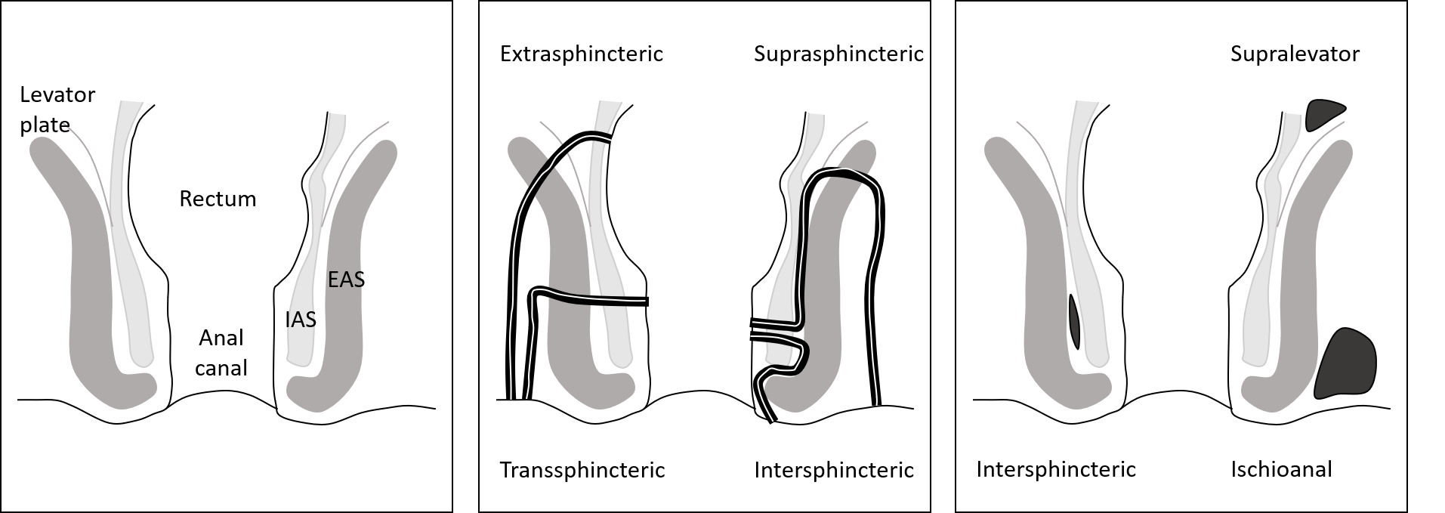
Intersphincteric
Perianal
A coronal view of the anal sphincter complex and fistula and abscesses which may occur. IAS – internal anal sphincter, EAS – external anal sphincter.
2.1.4.3.5.2 Colovesical fistula: An abnormal connection between the colon and bladder. Patients may complain of faecaluria or pneumaturia or present with recurrent urinary tract infections. NEW
2.1.4.3.5.3 Rectoprostatic fistula: An abnormal connection between the rectum and prostate. NEW
2.1.4.3.6 Anal / Perianal Sepsis: Presence of an abscess arising from the ano-rectum in the perianal, ischioanal, supralevator or intersphincteric compartments (Figure 1). This may be associated with a fistula. CHANGED
2.1.4.3.7 Rectal lesions: an abnormal area in the rectum, such as carcinoma. NEW
2.1.4.3.8 Extra rectal masses: An assessment can be made of the rectovesical pouch and presacral space by palpating for extra rectal masses. NEW
2.1.4.3.9 Prostate: The size and regularity of the prostate is assessed by palpation. NEW
2.1.4.3.10 Resting anal tone: subjective assessment of anal sphincter tone at rest. Can be graded as absent, weak, normal or strong. NEW
2.1.4.3.11 Squeeze anal tone: subjective assessment of pressure on the examiners finger on voluntary squeeze. Can be graded as absent, weak, normal or strong. NEW
2.1.4.3.12 Dyssynergia: the apparent increase in anal sphincter tone (anismus) or puborectalis tone (paradoxical puborectal contraction) on the examiner’s finger when the patient is asked to bear down. NEW
2.1.4.3.13 Rectal expulsion pressure: The subjective assessment of the rectal pressure on the examiner’s finger when the patient is asked to bear down. Can be graded as absent, weak, normal or strong. NEW
2.1.4.3.14 Intussusception: Intussusception will also fold in and may be palpable on the examiners finger. NEW
2.1.4.4 Anoscopy/ Proctoscopy: The use of a short anal retractor (anoscope (10cm long)/ proctoscope (13cm long)) to examine the anal canal and low rectum. NEW _{FN 2.6}
This will allow assessment of:
2.1.4.4.1 Bowel mucosa: lesions such as inflammation or malignancy.
2.1.4.4.2 Intussusception (see also 2.1.4.2.8)
2.1.4.4.3 Haemorrhoids (see also 2.1.4.2.7)
2.1.4.4.4 Anal fissures (see also 2.1.4.2.6)
2.1.4.5 Sigmoidoscopy/ Rectoscopy: The use of a rigid sigmoidoscope (25cm long) (may also be termed a rectoscope) (usually at the bedside) to examine the anal canal and rectum. NEW _{FN 2.7}
This will allow assessment of:
2.1.4.5.1 Bowel mucosa: Lesions such as inflammation or malignancy.
2.1.4.5.2 Intussusception (see also 2.1.4.2.8)
Footnotes Section 2:
FN 2. 1 Anorectal dysfunction may be associated with systemic disease, obesity and connective tissue disease and intestinal malignancy. Observe for cachexia, anaemia, jaundice and lymphadenopathy.
FN 2.2 It is recommended that the patient lies in the lateral position with hips flexed and ankles away from the examiner.
FN 2.3 A posterior anal fissure is caused by ischaemia and increased resting anal tone. Conversely an anterior anal fissure may be seen in a low pressure sphincter. If there is a fissure at another position then other pathologies such as Crohns, sexually transmitted diseases or malignancy should be considered.
FN 2.4 Grade II and Grade III haemorrhoids will become evident on asking the patient to bear down and grade IV haemorrhoids are obvious at the time of the examination. A proctoscopy is essential in examining for haemorrhoids unless they are completely prolapsed.
FN 2. 5 A recommended technique for digital rectal examination: The gloved lubricated finger is placed in the centre of the anus in the midline. The finger is pressed gently into the anal canal and backwards against the skin of the posterior wall of the anal canal and underlying sling of the puborectalis muscle. This overcomes the tone of anal sphincter and allows the finger to straighten and slip into the rectum. The patient is asked to: squeeze to assess voluntary squeeze of the anal sphincter and levator muscles, perform a sustained squeeze over 5 seconds, cough to elicit an involuntary contraction and strain.
FN 2.6 A recommended technique for anoscopy and proctoscopy: The lubricated anoscope or proctoscope is gently inserted into the anus, the introducer is removed, and the light source switched on. The patient is asked to bear down while the scope is in place and the scope is withdrawn whilst continuing to visualise the rectal mucosa.
FN 2.7 A recommended technique for rigid sigmoidoscopy: The lubricated rigid sigmoidoscope is gently inserted into the anus and the introducer is removed. Air is used to insufflate the rectum and the rectal folds are negotiated under direct vision so that the length of the rectum is intubated. As the scope is withdrawn the integrity of the rectal mucosa is visualised. The patient is also asked to strain so that the extent of any intussusception can be assessed.

SECTION 3: ASSESSMENT TOOLS AND QUESTIONNAIRES (non-invasive)
3.1 Pictorial stool chart: A pictorial chart of stool consistencies. The Bristol stool form scale (BSFS) is the most widely used pictorial stool chart. It comprises of 7 stools types ranging from hard (type 1) to watery diarrhoea (type 7) (16–18) (Figure 2). Type 3, 4 and 5 are considered ‘normal’ stool. Stool forms 1 and 2 are associated with slower transit, while stool forms 6 and 7 are associated with more rapid transit. _{FN 3.1}
Figure 2: The Bristol Stool Scale
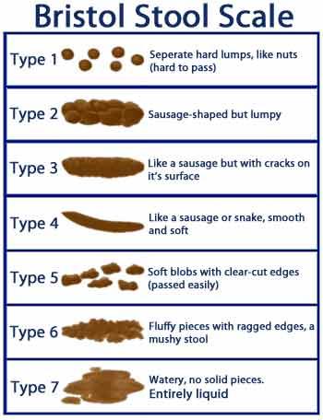
3.2 Bowel diary: A recording of bowel actions. _{FN 3.2}
Suggested elements are (2): Urgency, flatus and faecal incontinence (amount, consistency), passive staining/soiling (tends not to be discrete episodes), pads (changes, degree of soiling), straining/difficulty/time in the toilet, unsuccessful attempts to defaecate, assistive measures (e.g. digital stimulation, manual evacuation, irrigation, laxative or rectal evacuant use), diet and fluids (type and/or timing) and tenesmus. CHANGED
3.3 Symptom scores and questionnaires: Assessment tools which aim to quantify symptom severity by the use of self- or career-administered questionnaires (Appendix A). NEW
The Pelvic Floor Consortium, endorsed by the International Continence Society have recently published recommendations for measuring pelvic floor disorder symptoms using patient-reported instruments. The Cleveland Clinic Florida Incontinence Score and the St Mark’s Incontinence Score were recommended for the assessment of faecal incontinence. The Patient Assessment of Constipation and Constipation Severity Instrument were recommended for the assessment of constipation. The overall battery of validated instruments for the assessment of all pelvic floor disorder symptoms were combined to produce an Initial Measurement of Patient-Reported Pelvic Floor Complaints Tool (IMPACT), long and short forms (19).
3.3.1 Symptom scores and questionnaires which assess anal incontinence (AI):
3.3.1.1 The Cleveland Clinic Score (‘Wexner’ score): An assessment tool for physicians which examines frequency and consistency (solid, liquid, gas) of AI and its’ effect on lifestyle (pad usage, lifestyle alteration) (maximum score 20) (20). NEW _{FN 3.3}
3.3.1.2 The St Marks’ incontinence score (SMIS): An adapted version of the Wexner score. In addition to reporting the frequency of AI, the SMIS also includes scores for faecal urgency (problems deferring defaecation for more than 15 minutes) and anti diarrheals in the last four weeks (maximum score 24) (21). NEW _{FN 3.4}
3.3.1.3 The Revised Faecal Incontinence Scale (RFIS): A short, 5-item assessment tool which assesses AI (22). Points examined are frequency of incontinence with solid and liquid stool, urgency, the change of underwear and lifestyle alteration (maximum score 20). NEW _{FN 3.5}
3.3.1.4 ICI questionnaire—Bowels (ICIQ-B): A 24 point questionnaire developed by the international consultation on incontinence (ICI) which examines bowel symptoms and their impact upon quality of life and sexual matters (maximum scores - bowel pattern score 25, bowel control score 28, bowel pattern sexual impact 5, bowel patter sexual impact bother score 10, quality of life 26). NEW _{FN 3.6}
3.3.1.5 Faecal Incontinence Severity Index (FISI): A matrix questionnaire with four types of leakage (gas, mucus, liquid and solid stool) and six frequencies (maximum score 61). NEW _{FN 3.7}
3.3.1.6 Faecal Incontinence Quality of Life Scale (FIQOL): A 29-item questionnaire comprising four domains (lifestyle, coping/behaviour, depression/self-perception, embarrassment) with four separate domain scores (1 to 5) and no single summary measure (2). NEW _{FN 3.8}
3.3.2 Symptom scores and questionnaires which assess constipation: _{FN 3.9}
3.3.2.1 The Cleveland constipation scoring system (CCS): An 8 point questionnaire (frequency, painful evacuation, completeness of evacuation, abdominal pain, time on lavatory, assistance, unsuccessful attempts to evacuate and duration of constipation) with a maximal score of 30 (23). NEW _{FN 3.10}
3.3.2.2 Knowles Eccersley Scott Symptom (KESS) score: An 11 point questionnaire with 4 to 5 point Likert scales which is a modified version of the CCS designed to diagnose all forms of constipation (24,25) (maximal score of 39). NEW _{FN 3.11}
3.3.2.3 The Patient Assessment of Constipation (PAC): A self-reported assessment tool to measure symptoms of constipation (PAC-SYM) (Likert scale 0 – 4 for each symptom) and impact on HRQoL (PAC-QoL) (Likert scale 0 – 5 for each symptom) over the past two weeks (26,27). NEW _{FN 3.12}
3.3.2.4 The Constipation Severity Instrument: A Validated Measure: A self assessment instrument which measures three aspects; incomplete bowel movements, colonic inertia and pain (28). NEW _{FN 3.13}
3.3.3 Symptom scores and questionnaires which assess obstructed defaecation:
3.3.3.1 The Obstructed Defaecation score (ODS): An 8 point questionnaire (time on toilet, frequency, digitation, laxative and enema use, incomplete evacuation, straining, stool consistency) with a Likert scale for each symptom (maximum score 31) (2). NEW _{FN 3.14}

Footnotes Section 3:
FN 3.1 The Bristol stool form scale was developed based on the fact that a stool form scale can be used to monitor changes in intestinal function (18). It was recommended by the Rome Foundation for stool consistency assessment (29). Despite limited validation as an outcome measure, and uncertain precision with reported change between categories, the BSFS is widely accepted as useful in conversations with patients about their stool consistency (2).
FN 3.2 Bowel diaries are recordings of bowel habits widely used in diagnostic and intervention studies (2). Some studies suggest that patient reported stool frequency may be misleading, and that diaries tend to be more accurate and less susceptible to recall bias than reports based on patient recall only (30–32). Several Societies favour bowel diaries over self-reports for characterizing bowel habits and anal incontinence (33). Moreover, the use of bowel diary to track symptom severity and describe symptom patterns, may be useful in guiding therapy options (34). However, an accurate completion of bowel diaries warrants careful and detailed instruction of patients to avoid misinterpretations of the reported bowel habits. Despite the frequent use in both clinical setting and research, few examples of bowel diaries are published and no consensus has been reaches as to which elements should be included when reporting bowel actions
FN 3.3 The Cleveland Clinic Score was originally published as an assessment tool for physicians based on frequency and consistency of AI and its’ effect on lifestyle, and has subsequently been filled in by patients. The score does not measure faecal urgency, leakage amount or volume. The International Consultation on Incontinence (ICI) evaluated the attributes construct and criterion validity, internal consistency, test-retest reliability and responsiveness to be partly or adequately validated (34), and it has been recommended for use in both research and clinical practice (2). It is simple to use and easily understood by patients (21).
FN 3.4 Similar to the Wexner score, the SMIS has been shown to have part or adequate validity, consistency, reliability and clinical utility (21,34). The SMIS correlates well to patients’ global assessment of their bowel function (35), may be used as both an interview-based as well as a self-administered incontinence score and is recommended for use in research and clinical practice (2,36).
FN 3.5 The Revised Faecal Incontinence Scale was developed based on a large community survey and the examination of the psychometric properties of the Wexner score and other questions about AI. The aim was to provide a short assessment tool for use in outcome and epidemiological research as well as in clinical practice (22).
FN 3.6 The ICI aims to provide universally applicable questionnaires for use across international populations in clinical practice and research regarding bowel, urinary, bladder and sexual matters and their impact upon quality of life. The items in ICI questionnaire—Bowels(ICIQ-B) was developed by literature review, expert opinion and in-depth qualitative interviews with patients, thus the ICI Q-B includes items of greatest importance to both clinicians and people with AI symptoms (37,38). ICIQ-B does not report on leakage amount or volume, however, it is reported to be partly or adequately validated with regards to construct and criterion validity, internal consistency and test-retest reliability, however more work is needed for the attribute responsiveness to change (34). The ICI-Q B also evaluates Health Related Quality of Life (HRQoL), and was the top rated questionnaire for evaluation of symptoms severity and impact on HRQoL (39).
FN 3.7 The Faecal Incontinence Severity Index (FISI) was developed using items suggested by experts and then proposed to patients for ranking (40). It does not include reports of urgency, leakage amount or volume. Further work is needed for evaluating the FISI attributes of construct validity and internal consistency, however, criterion validity, test-retest reliability and responsiveness to change has been partly or adequately validated (34). The FISI has been recommended for use in research, but optional in clinical practice (2).
FN 3.8 Like the FISI, the items in the Faecal Incontinence Quality of Life Scale (FIQOL) was suggested by experts and then proposed to patients for ranking (41). The FIQL is recommended for use in research, but is regarded as an optional assessment tool in clinical practice (2).
FN 3.9 No grading of constipation questionnaires similar to the ICI’s evaluation of symptom severity and HRQoL assessment tools has been conducted.
FN 3.10 The Cleveland constipation scoring system (CCS) was developed based on interviews with patients experiencing constipation and correlates well with physiological findings. The CCS has been found to differentiate between colonic inertia and pelvic outlet obstruction (23).
FN 3.11 Validation of the KESS score has been limited.
FN 3.12 The Patient Assessment of Constipation (PAC) was developed based on literature review and patient focus group interviews to evaluate patient experiences with constipation over time (26,27). The validation process of PAC-SYM and PAC-QoL has been robust, and they are both recommended for use in clinical practice and research (2).
FN 3.13 The Constipation Severity Instrument was developed to produce three subscales (obstructive defaecation, colonic inertia, pain) based on a literature review and focus groups of both patients and medical providers. Test-retest reliability were high for all subscales (28).
FN 3.14 Patients with obstructed defaecation symptoms may be difficult to identify. The first score specifically designed for this patient group was the Obstructed Defaecation score (ODS), which was based on items from the Cleveland Clinic Constipation scoring system and the KESS score. The ODS aims to grade symptom severity and monitor treatment outcomes (24). Moreover, the authors suggest that the ODS may be able to discriminate between clustering of symptoms associated with dyssynergia (rectal digitation) and fragmented defaecation (rectocele, intussusception or prolapse) (24). The ODS is recommended for use in research, however, further formal validation is needed (2).
SECTION 4: ANORECTAL PHYSIOLOGICAL INVESTGATIONS
Functional assessment tests of anal incontinence and evacuatory disorders which aim to qualify and quantify function, determine the aetiology, guide management, and monitor progress.
For all tests of anorectal physiology there is variation in technology, data acquisition and analysis. The reliability, reproducibility and clinical validity of these tests are largely unproven. The international anorectal physiology working group recommends standard techniques for a minimum standard of anorectal physiology, with a focus on high resolution anorectal manometry (42). Normative datasets are yet to be published; in the interim each individual unit should establish standardised techniques and sets of normal values (43,44). These limitations must be considered when reviewing the techniques and ‘normal’ values presented below. Table of evidence for the clinical use for anorectal physiology investigations in Appendix B Section 1 Table 1.
4.1

Anorectal manometry: The use of catheter (manometer) in the anorectal canal to measure pressure along the anorectal canal.
Anorectal manometry is the most widely used test to assess the mechanical strength of the anal sphincter muscles and/ or anorectal co-ordination (45). CHANGED
The clinical application of manometry is in Appendix B Section 2.
4.1.1 Conventional anal manometry: A catheter (manometer) where pressure is measured at a single point. The length of the canal is measured either by station pull-through or continuous pull-through. NEW _{FN 4.1}
4.1.2 High definition anal manometry: A catheter with 256 solid state microtransducers placed circumferentially 3mm apart. NEW
4.1.3 High resolution anal manometry: The conventional anal manometry catheter is used in combination with the high definition software. Standard catheters (solid state pressure sensors or water perfused) can be used with specialised software to display pressures in real time along the length of the anal canal. Pressure readings from the length of the anal canal are recorded simultaneously, in real time to demonstrate the intra-anal pressure environment. _{FN 4.2} This allows complete definition of the intra-anal pressure environment. Normal ranges are higher than with standard manometry (46). _{FN 4.3} An emerging technique which is being used more frequently in clinical practice. NEW
4.1.4 The following parameters may be recorded during anorectal manometry:
4.1.4.1 Functional anal canal length: The length of the anal canal over which resting pressure exceeds that of the rectum by greater than 5 mm Hg or, alternatively, the length of the anal canal over which pressures are greater than half of the maximal pressure at rest (2).
4.1.4.2 Maximum resting pressure: The maximum resting pressure generated in the anal canal at rest. Strictly speaking, the difference between the intrarectal pressure and the highest recorded rectal pressure at rest. However, rectal contents may affect the accuracy of rectal pressure measurements. The mean maximum resting pressure is the maximum resting pressure of the mean of all the radial channels at a single level in the anal canal (mm Hg). CHANGED _{FN 4.4}
4.1.4.3 Maximum squeeze pressure: The maximum pressure generated in the anal canal during a voluntary contraction. The mean maximum squeeze pressure is the maximum squeeze pressure of the mean of all the radial channels at a single level in the anal canal mm Hg). CHANGED _{FN 4.5}
4.1.4.4 Cough pressure: The reflex increase in anal sphincter pressure during a cough (i.e. an abrupt change in intra-rectal pressure as a surrogate marker for intra-abdominal or intra-pelvic pressure) (47). NEW
4.1.4.5 The length from the anal verge to the peak pressure: The distance from the anal verge to the mean maximum resting pressure or mean maximum squeeze pressure (mm). NEW
4.1.4.6 The high-pressure zone length (HPZ): The length of anal canal where the mean radial pressure is over fifty percent of the mean maximal pressure (mm). NEW
4.1.4.7 Involuntary maximum squeeze pressure: A common manoeuvre is a maximal cough to measure this involuntary increment, usually reported as a present or absent response, rather than numerically (2).
4.1.4.8 Endurance squeeze pressure: The length of time the individual can maintain the pressure during a voluntary contraction (Appendix B Section 3). CHANGED
4.1.4.9 The average anal canal pressure: The average of the mean radial pressures along the length of the vector volume plot either at rest or when squeezing (average of readings taken at 1mm intervals in the automated vector manometry and 5mm for the station manometry measured in mm Hg). NEW
4.1.4.10 Rectoanal inhibitory reflex (RAIR): RAIR is a relaxation response of the IAS following rectal distension which underlies the sampling response that allows the anal mucosa to detect the nature of rectal contents to allow continence (48). It is present if there is a drop of at least 25 % of resting pressure with subsequent restoration to at least two thirds of resting pressure (2). _{FN 4.6}
4.1.4.11 Balloon expulsion pressure: The anal canal pressure during straining with a balloon in the rectum. Performed in patients with evacuatory difficulty. Increased sphincter pressure during straining is labelled ‘anismus’ or ‘paradoxical sphincter contraction’. There are four types of dyssynergy which can be identified at balloon expulsion during anal manometry (Figure 3) (49). CHANGED

Figure 3: Normal and anismic balloon expulsion pressure on high definition anal manometry
Normal
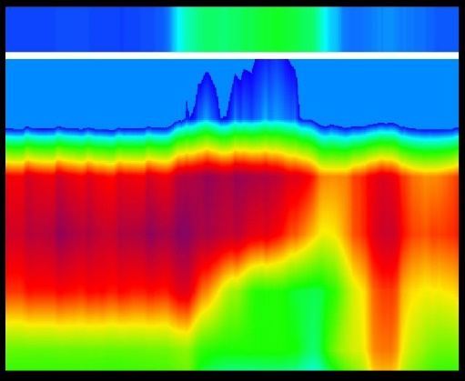
Anismus
Type I: The patient can generate an adequate push (increase in rectal pressure) but there is also a paradoxical rise in anal sphincter pressure. | Type II: The patient cannot generate an adequate push (no increase in intrarectal pressure) and there is a paradoxical rise in anal sphincter pressure.
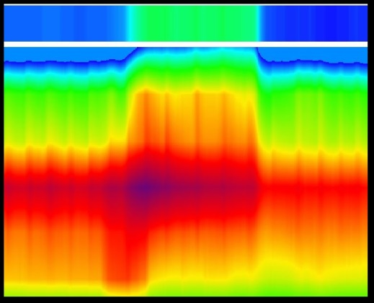 | 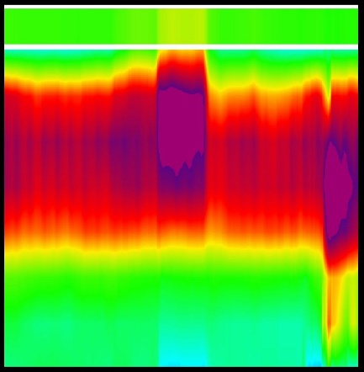
Type III: The patient can generate an adequate push (increase in rectal pressure) but there is either absent or incomplete sphincter relaxation. | Type IV: The patient cannot generate an adequate push and demonstrates absent of incomplete sphincter relaxation (49).
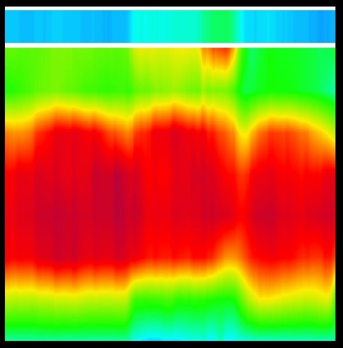 | 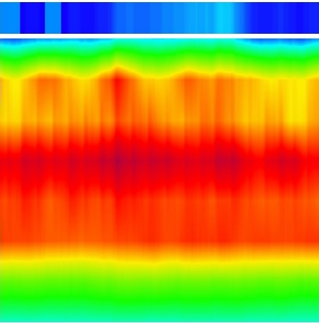

4.2 Advanced manometric techniques: techniques which are not yet routine but allow further information to be gained from anorectal manometry. NEW
4.2.1 Vector manometry: A quantitative measure of radial symmetry and volume of the anal sphincter producing a three-dimensional picture of anal canal function. _{FN 4.7} The following parameters are identified: CHANGED
4.2.1.1 Anal canal symmetry: can be expressed as total radial asymmetry or as vector symmetry index (VSI). Radial asymmetry expresses the degree to which the integrated cross sections deviate from a perfect circle. If in a single cross-section the pressure readings from all the channels are the same, the radial asymmetry would be zero percent. The VSI is expressed as a value from 0 to 1, with values closer to 0 indicating greater asymmetry. NEW
4.2.1.2 The vector volume (three-dimensional) of pressure: depends on the number of channels used with more channels giving a higher vector volume. NEW _{FN 4.8}
4.2.2 Ambulatory manometry: Manometry left in situ monitoring while patient mobilises (50). CHANGED _{FN 4.9}
4.3 Sensory measurements: an intrarectal balloon is serially inflated to determine rectal sensation. Rectal balloon test or barostat are both used for sensory measurements. Clinical application for measuring sensation in Appendix B Section 4. NEW
4.3.1 Rectal balloon test: Sensitivity to the inflation of a rectal balloon _{FN 4.10} (Appendix B Section 5). Methods for balloon distention are poorly standardised (51). See Appendix B Section 6 for measurements. NEW
4.3.2 Barostat: Electromechanical device which provides constant pressures to inflate an intrarectal balloon to allow rectal sensitivity testing. NEW
The barostat may be more reproducible than balloon distention but the published ranges still vary widely between centres (52,53). The distension thresholds are typically 1.5 to 3 times higher than for manual balloon inflation and may take up to an hour to perform (51). Although the technology is not yet widely available the development of a ‘rapid’ barostat could enable its’ use in routine clinical practice (54).
4.3.3 Rectal impedance planimetry: Measurement of the pressure required to open the anal canal (2).
Pressure required to open the anal canal. Rectal impedance planimetry measures the cross-sectional area of an intrarectal bag during distension to enable the circumferential wall tension to be calculated (55). This is primarily used for research purposes.
4.4 Balloon expulsion test: Attempt to expel an intrarectal balloon. NEW _{FN 4.12}
4.5 Anorectal neurophysiology (Male): Assessment of the conduction of the pudendal and spinal nerves, and electromyography (EMG) of the anal sphincter muscles. _{FN 4.13}
4.5.1 EMG: Electromyographic traces are recorded from the separate components of the sphincter complex both at rest and during active contraction of the striated components. CHANGED _{FN 4.14}
4.5.2 Pudendal nerve terminal motor latencies (PNTMLs): Pudendal nerve conduction is assessed by stimulating as the nerve enters the ischio-rectal fossa at the ischial spines. CHANGED
Prolonged latencies indicate pudendal neuropathy (demyelination or damage) (56). However, this investigation only examines the fastest conducting fibres of the pudendal nerve and so can still be normal even in the presence of abnormal sphincter innervation. _{FN 4.15}
4.5.3 Mucosal electro sensitivity: This measurement of anal and rectal sensory thresholds using a probe with two ring electrodes (2). _{FN 4.16}

Footnotes Section 4:
FN 4.1 Station pull-through involves inserting the catheter to 6 cm from the anal verge, withdrawing the catheter at 5–10 mm intervals and measuring for 1–5 min at each “station”. Continuous pull-through involves withdrawing the catheter at a set speed by hand or by a mechanical puller.
FN 4.2 The probe is placed into the anal canal. The international anorectal physiology working group recommend the following timeline for examination – stabilisation period for three minutes, rest 60 seconds, three short squeeze for 5 seconds each with 30 second recovery internal between short squeezes, long squeeze 30 seconds, 60 seconds recovery, two cough, three fifteen second push with 30 seconds recovery between each followed by rectal sensory testing and the rectoanal inhibitory reflex.
The data is displayed on a topographical three-dimensional plot to allow easier pattern recognition. Pressure (atmospheric mm Hg) is displayed as graduated colour (-6 – 0 blue, 0 – 20 turquoise, 20 – 40 green, 40 – 60 light green, 60 – 70 yellow, 70 – 80 orange, 80 – 110, 110 – 140 purple), distance into the anal canal is the y-axis and time is the x-axis.
FN 4.3 Normal ranges for all anorectal physiology are not comparable between systems and different centres due to variability in practice (44).
FN 4.4 The internal anal sphincter (IAS) exhibits continuous tonic activity and is responsible for 55–85 % of the resting anal canal pressure. Its contribution to resting tone is variable along the length of the anal canal with the proximal two thirds being more reliant on IAS tone to maintain adequate resting pressures (57,58). The range of maximal resting pressure is typically 60 to 120 cm H₂O. The EAS has constant tonic activity contributing to the resting anal canal pressure
FN 4.5 Although the external anal sphincter (EAS) contributes to the resting pressure the specific function of the EAS can be assessed during the squeeze and cough manoeuvres. The pressure increment above resting pressures during these manoeuvres is a direct representation of EAS function. Usually, the normal range is above 60 cm H₂O (59,60). Higher values are obtained by automated pull-through rather than station withdrawal methodologies.
FN 4.6 Fifty ml of air is used to rapidly insufflate a balloon which is placed in the distal rectum at the level of the proximal high-pressure zone. RAIR is absent in Hirschsprung’s disease.
FN 4.7 A radially arranged multi-channel anorectal manometry catheter is withdrawn (commonly using a mechanical puller) through the length of the anal canal.
FN 4.8 Vector volume parameters correlate with imaging and incontinence scores, but it is not routinely used in clinical practice – in the future it may be useful for treatment selection and preoperative patient assessment (61).
4.9 Examination of patients with ambulatory monitoring may help better understand the mechanism of action or the side effects of treatments. The routine clinical use of ambulatory monitoring has not been established.
FN 4.10 A balloon inserted into the rectum attached to a catheter and inflated at a rate of approximately 5 ml/s (58,59). Normal volumes for sensation will depend on the size and shape of the balloon.
FN 4.11 Normal ranges for urge sensation and maximum tolerated volume are highly variable due to lack of consensus on measurement technique especially of the nature and speed of inflation of the balloon.
FN 4.12 Failure to expel a balloon within one minute is frequently used to diagnose pelvic floor dyssynergia (62,63). However, the clinical accuracy of this technique is questioned and there is variation in the substance (water or air) and the volume (a set volume, for example 60mls or the urge volume) used to fill the balloon. Some units teach patients to expel the balloon and this may be used as a biofeedback tool (clinical response in up to 85% of patients) (64–66). The inability to expel a water filled balloon in patients may not exclude the presence of dyssynergy on defaecation proctography (though this is also not necessarily an accurate representation of dyssynergy) (67,68). Some have shown agreement between the balloon expulsion test and anorectal manometry (balloon expulsion pressure) (63) for the diagnosis of dyssynergy while others have found considerable disagreement between the two (68).
FN 4.13 In patients with anal incontinence likely due to neurological injury, anorectal neurophysiology can identify pudendal nerve damage (stretch injury secondary to straining during constipation). Anorectal neurophysiology can also be used in patients with anorectal pain and complex pelvic floor disorders, especially before surgery (2,44,51).
FN 4.14 Purpose of EMG: Reflects the activity of the striated musculature (peri-urethral, rhabdosphincter and pelvic floor). EMG is poorly standardized with variance in the type of needle, needle versus patch electrode and electrode placement⁹³. Perineal patch electrodes are often preferred for easier placement, patient tolerance and allow greater mobility. However, they measure all the above striated musculature. In contrast, needle electrodes can be placed in the area of interest and measure activity of defined muscles or muscle groups e.g. rhabdosphincter. Interpretation may be difficult due to artefacts introduced by other equipment.
FN 4.15 The normal value for pudendal nerve terminal motor latency (PNTML) is 2.0 ± 0.5 milliseconds but is operator dependent and so not recommended for routine clinical use (69).
FN 4.16 Mucosal electrical stimulation is performed using a probe with two ring electrodes between which a small electrical potential is applied generating an alternating square wave with a variable frequency. Normal anal electro-sensation is <10 mA and normal rectal electro-sensation is <30 mA (70). Prolonged anal electro-sensation suggests damage to the sensory fibres of pudendal nerve and prolonged rectal electro-sensation suggests autonomic neuropathy.
SECTION 5: ANO RECTAL IMAGING

Ultrasound of the anal sphincters and pelvic floor muscles. (Endoanal, Transperineal)
5.1 Endoanal ultrasound: Endoluminal ultrasound scanning of the anal canal. CHANGED
5.1.1 Static Endoanal Ultrasound: Endoanal ultrasound in a stationary position. NEW
5.1.1.1 2D ultrasound: an axial image is captured at any point along the anal canal.
5.1.1.2 3D ultrasound with manual acquisition: serial axial images captured along the anal canal while manually withdrawing the endoluminal probe. These images are used to build a 3D image of the entire anal canal. This method cannot be used to measure cranio-caudal length along the anal canal.
5.1.1.3 High resolution 3D ultrasound with computer controlled acquisition: the endoluminal probe contains an automated internal transducer to acquire serial images in either the axial or sagittal plane while the probe is held still in the anal canal. The serial images are used to build a 3D image of the entire anal canal which can accurately measure cranio-caudal anal canal lengths.
Endoanal ultrasound techniques are in Appendix C Section 1, clinical Application of EAUS in Appendix C Section 2.
5.1.2 Normal anatomy: In the axial plane, the anal canal is divided into three levels (upper, middle and lower) and the anal sphincter complex is examined (Figure 4). NEW _{FN 5.1}
5.1.3 Parameters measured: The anterior aspect of the anal canal is at the top of the screen (12 o’clock) and left lateral is right (3 o’clock) on the screen (assuming the patient is supine and looking from caudal to cranial). NEW
5.1.3.1 Internal anal sphincter thickness: The radial width of the internal anal sphincter is measured at 3 o’clock and 9 o’clock in its’ thickened position/ at the mid anal canal.
5.1.3.2 Anal sphincter integrity: The radial extent and cranio-caudal extent of a sphincter injury (complete disruption or scarring) is described for the internal anal sphincter and external anal sphincter. The radial extent is described with relation to the clockface and often localised to a quadrant.
5.1.4 Fistula and sepsis: The position of fistula and sepsis on endoanal ultrasound can be described.
Figure 4: Endoanal ultrasound of the anal sphincter complex
Upper level: The sling of the puborectalis (PR) and the complete ring of IAS. | Middle level: The EAS (complete ring) (black arrow), the longitudinal muscle (black dashed arrow), the IAS (complete ring) (white arrow), the transverse perineii muscles.
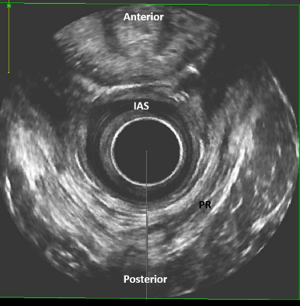 | 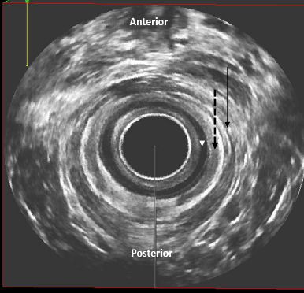
Lower level: The subcutaneous part of the EAS. The IAS has terminated. | Sagittal view: The IAS and EAS are visualised.
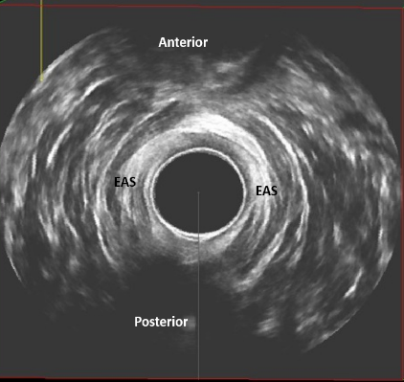 | 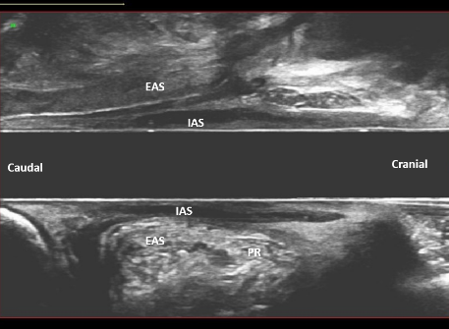
Coronal view: The IAS and EAS are visualised.
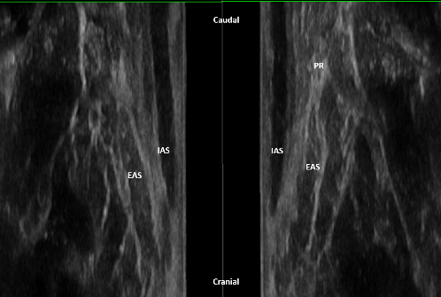
IAS – internal anal sphincter, EAS – external anal sphincter, PR - puborectalis
5.1.5 Other endoanal techniques: The following methods are not routinely performed.
5.1.5.1 Dynamic endoanal ultrasound: The acquisition of endoanal ultrasound and rest and during straining. NEW
5.1.5.2 Echodefaecography: Endoanal ultrasound at rest and during attempted evacuation of rectal ultrasound gel. NEW
5.2 Transperineal ultrasound (Male): Ultrasound scanning on the perineum. NEW. Technique of transperineal ultrasound in Appendix C Section 3. How to perform in appendix. Clinical Applications of Transperineal Ultrasound are in Appendix C Section 4.
Figure 5: Transperineal ultrasound
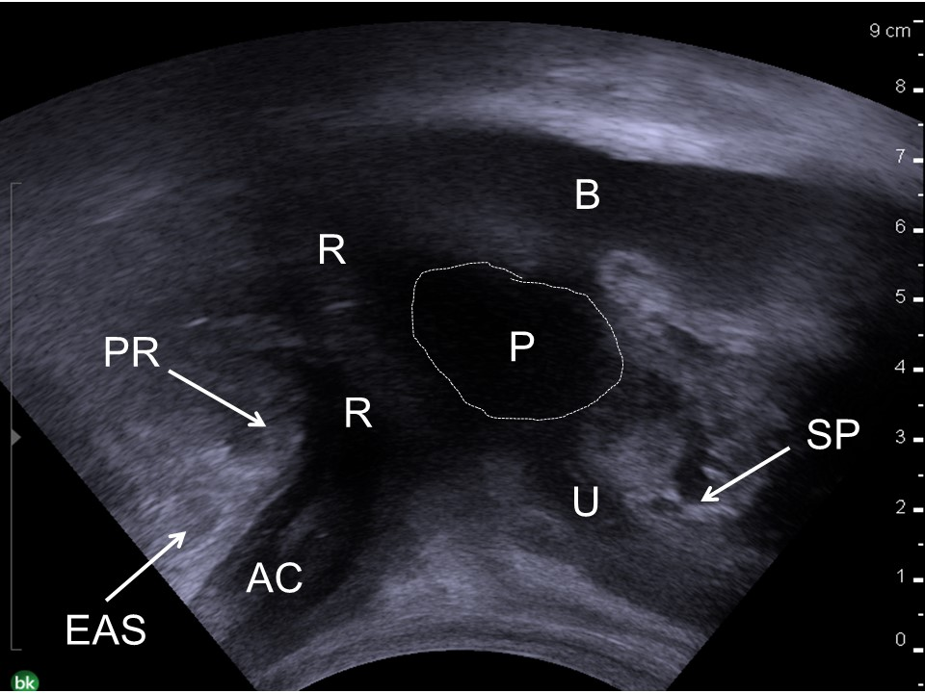
Transperineal US in male (SP: symphisis pubis; B: bladder; U: urethra; P. prostate; PR: puborectalis muscle; EAS: external anal sphicnter; R. rectum; AC: anal canal)
5.3 MRI
Clinical applications of MRI of the posterior compartment are in Appendix C Section 5.
5.3.1 Static MRI: MRI at rest for examination of the anal sphincter complex and entire pelvic floor (Figure 6). CHANGED
Figure 6: MRI
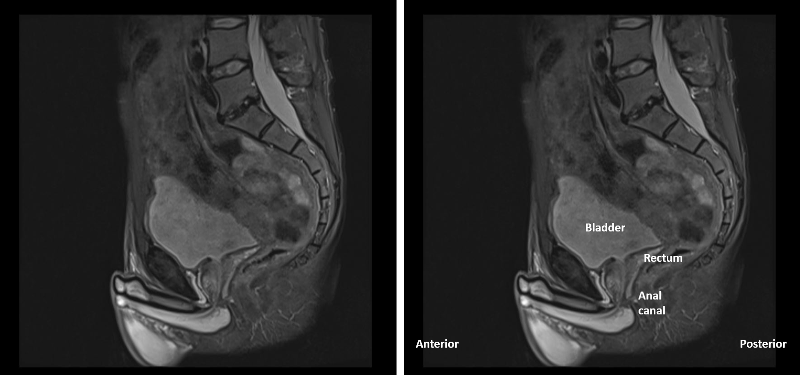

5.3.2 Endoluminal MRI: An endoanal or endorectal coil is inserted into the anus during static MRI. CHANGED
5.3.3 Dynamic MRI: MRI performed under dynamic conditions (relaxing, straining) for the examination of the pelvic floor and pelvic organs. CHANGED
5.3.4 MR defaecography (Defaecation MRI): Dynamic MRI performed during the expulsion of a rectal contrast agent (ultrasound gel, mashed potatoes or gadolinium-based MR contrast agent) (71,72). NEW
5.4 Fluoroscopic Barium defaecography: A dynamic investigation of rectal emptying involving the voluntary expulsion of rectal Barium paste recorded on fluoroscopy (73,74) (Figure 7). CHANGED
Clinical applications of defaecating proctography are in Appendix C Section 6.
Figure 7: Fluoroscopic Barium Defaecography
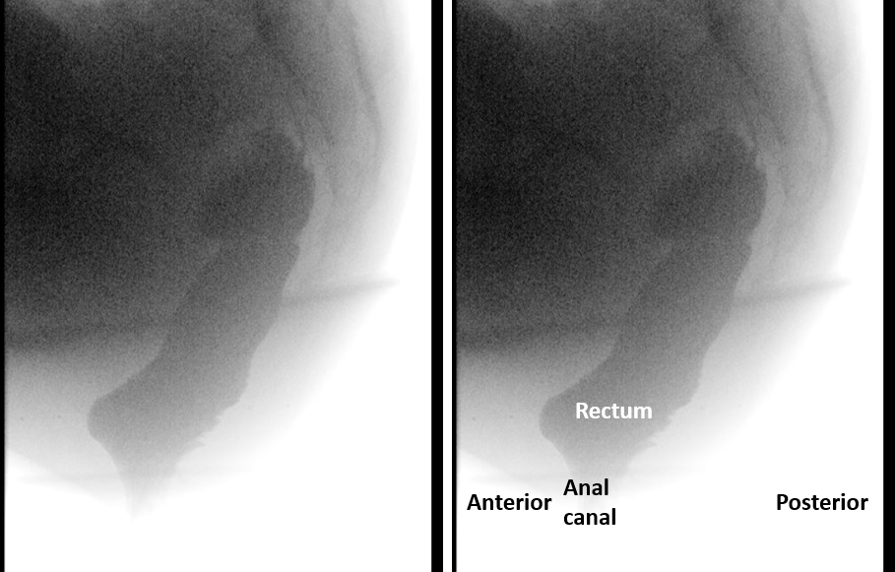

5.5.1 Colonic transit study: Colonic transit time is assessed with the use of radio-opaque markers and sequential abdominal X-rays. CHANGED. Technique in Appendix C Section 8.
5.5.2 Scintographic transit study: Segmental and total transit time is assessed with the use of 111 Indiumlabeled polystyrene (111ln-DTPA) micropellets and sequential Colon scintigraphy [108]. CHANGED. Technique in Appendix C Section 9.
5.6 Porridge enema: The insertion of porridge into the rectum to assess continence. NEW _{FN 5.2}
Clinical application of porridge enema in Appendix C Section 10.
5.7 Colonoscopy, Contrast enema, CT Colonography
Prior to the investigation and treatment of benign and functional anorectal dysfunction it is vital that organic disease is excluded.
5.7.1 Colonoscopy: An optical colonoscope is used to intubate the colon and terminal ileum. CHANGED
Clinical application of colonoscopy in Appendix C Section 11.
5.7.2 Contrast enema
5.7.2.1 Single-contrast enema: Using an appropriate catheter, a barium-water mixture or a water-soluble solution of diatrizoate sodium (Gastrografin©) is inserted into the colon with the patient in the prone position until the column of barium reaches the splenic flexure (2). CHANGED
5.7.3 CT Colonography: Prior to CT scan the patient undergoes bowel cleansing and ingests oral contrast agent suspension for faecal tagging. The colon is distended with carbon dioxide and CT scanning performed in at least two positions, typically supine and prone. NEW
Clinical application of contrast enema and CT enema in Appendix C Section 12.

Footnotes Section 5:
FN 5.1 Sex differences The EAS is generally thicker in males, although this is probably related more to body mass than to gender. The IAS does not seem to differ significantly between males and females. The greatest difference lies in the anterior arrangement of the EAS and in the perineal body. The LM and EAS are more or less symmetrical in the male, so the coronal and sagittal sections are comparable. This is not so in the female, where the EAS slopes down as it runs around the canal to form a complete anterior ring low in the perineum. The EAS is therefore shorter anteriorly than posteriorly. The effect of this on axial scanning is that high in the anal canal there appears to be a defect anteriorly. The PB in the male represents a central fibromuscular area where the fibres from the decussating parts of the EAS fuse with those from the transverse perineii and bulbospongiosus. The PB is larger in the female.
FN 5.2 The rectum is filled with 100 – 150 ml of porridge and the patient asked to walk around for 30 minutes.

SECTION 6: DIAGNOSES (Most Common)
Diagnosis: The determination of the nature of a disease; clinical: made from a study of the symptoms and signs of a disease, laboratory: investigative options/ procedures to be mentioned.
The diagnoses are categorized according to subgroups that reflect the function of the anorectum, namely defaecatory dysfunction, anorectal incontinence, anorectal pain and sexual function.
6.1. Obstructed defaecation: incomplete evacuation of faecal contents from rectum during defaecation attempts. It includes symptoms such as straining to defaecate, sensation of blockage, digitation, and splinting. Associated features of obstructed defaecation are 1: Intussusception: Full thickness invagination of the upper rectum without extrusion through the anus leading to interruption of ﬂow of the faecal stream; 2: Internal mucosal prolapse: Mucosal prolapse of the anterior, posterior, or circumferential mucosal layer. 6: External rectal prolapse: Full thickness rectal prolapse outside the anal canal (2). Blockage can also occur by a failure to relax the pelvic floor when attempting to defaecate (dyssynergia or anismus). CHANGED
6.1.1. Non-Relaxing Puborectalis: A situation in which the pelvic floor muscles do not relax, or may even contract, when relaxation is functionally needed. For example, during micturition or defaecation. This condition is based on symptoms such as voiding problems, obstructed defaecation, or dyspareunia and on signs like the absence of voluntary pelvic floor muscle relaxation (75).
6.2 Irritable Bowel Syndrome (IBS) – Functional: i. Recurrent episodes of abdominal pain. ii. Changes in frequency, form or consistency of the stool. iii. Sensation of incomplete evacuation, straining, faecal urgency. iv. Sensation of nausea, fatigue, fullness, vomiting. v. Recurrent abdominal pain or discomfort at least 3 days/month in the last 3 months associated with two or more of the following: 1. Improvement of pain with defaecation. 2. Onset associated with change in frequency of stool. 3. Onset associated with a change in the form (appearance) of stool (76).
6.3 Faecal incontinence (Male): A diagnosis by clinical history and assisted, at times by the results of examination and diagnostic tests involving the confirmation of leakage of faeces (passive or urge) or flatus. NEW
6.3.1 Anal Sphincter Injury (Male): Injury to either the internal or anal sphincters. Most commonly iatrogenic but also seen following trauma and can lead to faecal incontinence. NEW
6.3.2 Underactive Anal and Pelvic Floor Muscles (Male): A situation in which the pelvic floor muscles cannot voluntarily contract when this is appropriate. This condition is based on symptoms such as urinary incontinence, anal incontinence or pelvic organ prolapse, and on signs like no voluntary or involuntary contraction of the pelvic floor muscles. NEW
6.4: Chronic (persistent or recurrent) Anorectal Pain Syndrome: Chronic Proctalgia—rectal pain, more than 20min of duration per episode, for at least 3 months with symptom onset at least 6 months prior to diagnosis. i. Persistent or recurrent rectal pain. ii. Rectal pressure or aching episodes. iii. In the absence of other causes of rectal pain. 2. Levator Ani Syndrome (the term may refer to the same syndrome as ‘‘pelvic ﬂoor muscle pain syndrome’’/ ‘‘tension myalgia of the PFM’’). i. Pain with sitting. ii. Pain with defaecation. 3. Proctalgia Fugax i. Severe recurrent episodic pain localized in the anus or lower rectum. ii. Duration seconds to minutes. iii. No pain between episodes (7).
6.4.1 Chronic Proctalgia: rectal pain, more than 20min of duration per episode, for at least 3 months with symptom onset at least 6 months prior to diagnosis. i. Persistent or recurrent rectal pain. ii. Rectal pressure or aching episodes. iii. In the absence of other causes of rectal pain (7). NEW
6.4.2 Levator Ani Syndrome (the term may refer to the same syndrome as ‘‘pelvic ﬂoor muscle pain syndrome’’/ ‘‘tension myalgia of the PFM’’): i. Pain with sitting. ii. Pain with defaecation (7). NEW
6.4.3 Proctalgia Fugax: Severe recurrent episodic pain localized in the anus or lower rectum. ii. Duration seconds to minutes. iii. No pain between episodes (7). NEW
6.5 Sexual dysfunction (Male): A diagnosis by clinical history (including specific questionnaires) and examination, involving the confirmation of abnormal function and/or difficulty with sexual intercourse. NEW
ACKNOWLEDGEMENTS / ADDENDUM:
We would like to thank Liliana Bordeianou, Professor Anton Emmanuel, Professor Stuart Taylor and Professor Steve Wexner for their invaluable review and comments of this paper. No discussion on terminology should fail to acknowledge the fine leadership shown by the ICS over many years. The legacy of that work by many dedicated clinicians and scientists is present in all the Reports by the different Standardization Committees and Working Groups. It is pleasing that the ICS leadership has accepted this vital initiative as a means of progress in this important and most basic area of Terminology and its Standardization. We gratefully acknowledge contributions from Samantha Morris for some of the images.

References
1. Haylen BT, de Ridder D, Freeman RM, Swift SE, Berghmans B, Lee J, et al. An International Urogynecological Association (IUGA)/International Continence Society (ICS) joint report on the terminology for female pelvic floor dysfunction. Neurourol Urodyn. 2010;29(1):4–20.
2. Sultan AH, Monga A, Lee J, Emmanuel A, Norton C, Santoro G, et al. An International Urogynecological Association (IUGA)/International Continence Society (ICS) joint report on the terminology for female anorectal dysfunction. Neurourol Urodyn. 2017;36(1):10–34.
3. D’Ancona C, Haylen B, Oelke M, Abranches-Monteiro L, Arnold E, Goldman H, et al. The International Continence Society (ICS) report on the terminology for adult male lower urinary tract and pelvic floor symptoms and dysfunction. Neurourol Urodyn. 2019;38(2):433–77.
4. Haylen BT, Maher CF, Barber MD, Camargo S, Dandolu V, Digesu A, et al. An International Urogynecological Association (IUGA)/International Continence Society (ICS) joint report on the terminology for female pelvic organ prolapse (POP). Int Urogynecology J. 2016 Apr;27(4):655–84.
5. Gajewski JB, Schurch B, Hamid R, Averbeck M, Sakakibara R, Agrò EF, et al. An International Continence Society (ICS) report on the terminology for adult neurogenic lower urinary tract dysfunction (ANLUTD). Neurourol Urodyn. 2018;37(3):1152–61.
6. de Bernis L. Obstetric fistula: guiding principles for clinical management and programme development, a new WHO guideline. Int J Gynaecol Obstet Off Organ Int Fed Gynaecol Obstet. 2007 Nov;99 Suppl 1:S117-121.
7. Doggweiler R, Whitmore KE, Meijlink JM, Drake MJ, Frawley H, Nordling J, et al. A standard for terminology in chronic pelvic pain syndromes: A report from the chronic pelvic pain working group of the international continence society. Neurourol Urodyn. 2017 Apr;36(4):984–1008.
8. Hashim H, Blanker MH, Drake MJ, Djurhuus JC, Meijlink J, Morris V, et al. International Continence Society (ICS) report on the terminology for nocturia and nocturnal lower urinary tract function. Neurourol Urodyn. 2019;38(2):499–508.
9. Rosier PFWM, de Ridder D, Meijlink J, Webb R, Whitmore K, Drake MJ. Developing evidence-based standards for diagnosis and management of lower urinary tract or pelvic floor dysfunction. Neurourol Urodyn. 2012 Jun;31(5):621–4.
10. Billecocq S, Bo K, Dumoulin C, Aigon A, Amarenco G, Bakker E, et al. [An International Urogynecological Association (IUGA)/International Continence Society (ICS) joint report on the terminology for the conservative and non-pharmacological management of female pelvic floor dysfunction]. Progres En Urol J Assoc Francaise Urol Soc Francaise Urol. 2019 Mar;29(4):183–208.
11. Rogers RG, Pauls RN, Thakar R, Morin M, Kuhn A, Petri E, et al. An International Urogynecological Association (IUGA)/International Continence Society (ICS) joint report on the terminology for the assessment of sexual health of women with pelvic floor dysfunction. Neurourol Urodyn. 2018;37(4):1220–40.
12. Bo K, Frawley HC, Haylen BT, Abramov Y, Almeida FG, Berghmans B, et al. An International Urogynecological Association (IUGA)/International Continence Society (ICS) joint report on the terminology for the conservative and nonpharmacological management of female pelvic floor dysfunction. Neurourol Urodyn. 2017;36(2):221–44.
13. Toozs-Hobson P, Freeman R, Barber M, Maher C, Haylen B, Athanasiou S, et al. An International Urogynecological Association (IUGA)/International Continence Society (ICS) joint report on the terminology for reporting outcomes of surgical procedures for pelvic organ prolapse. Int Urogynecology J. 2012 May;23(5):527–35.
14. Feusner JD, Phillips KA, Stein DJ. Olfactory reference syndrome: issues for DSM-V. Depress Anxiety. 2010 Jun;27(6):592–9.
15. Parks AG. Pathogenesis and Treatment of Fistula-in-Ano. Br Med J. 1961 Feb 18;1(5224):463-460.2.
16. O’Donnell LJ, Virjee J, Heaton KW. Detection of pseudodiarrhoea by simple clinical assessment of intestinal transit rate. BMJ. 1990 Feb 17;300(6722):439–40.
17. Heaton KW, Radvan J, Cripps H, Mountford RA, Braddon FE, Hughes AO. Defecation frequency and timing, and stool form in the general population: a prospective study. Gut. 1992 Jun;33(6):818–24.
18. Lewis SJ, Heaton KW. Stool form scale as a useful guide to intestinal transit time. Scand J Gastroenterol. 1997 Sep;32(9):920–4.
19. Bordeianou LG, Anger J, Boutros M, Birnbaum E, Carmichael JC, Connell K, et al. Measuring pelvic floor disorder symptoms using patient-reported instruments: proceedings of the consensus meeting of the pelvic floor consortium of the American Society of Colon and Rectal Surgeons, the International Continence Society, the American Urogynecologic Society, and the Society of Urodynamics, Female Pelvic Medicine and Urogenital Reconstruction. Tech Coloproctology. 2020 Jan 1;24(1):5–22.
20. Jorge JMN, Wexner SD. Etiology and management of faecal incontinence. Dis Colon Rectum. 1993 Jan 1;36(1):77–97.
21. Vaizey CJ, Carapeti E, Cahill JA, Kamm MA. Prospective comparison of faecal incontinence grading systems. Gut. 1999 Jan;44(1):77–80.
22. Sansoni J, Hawthorne G, Fleming G, Marosszeky N. The revised faecal incontinence scale: a clinical validation of a new, short measure for assessment and outcomes evaluation. Dis Colon Rectum. 2013 May;56(5):652–9.
23. Agachan F, Chen T, Pfeifer J, Reissman P, Wexner SD. A constipation scoring system to simplify evaluation and management of constipated patients. Dis Colon Rectum. 1996 Jun;39(6):681–5.
24. Altomare DF, Spazzafumo L, Rinaldi M, Dodi G, Ghiselli R, Piloni V. Set-up and statistical validation of a new scoring system for obstructed defaecation syndrome. Colorectal Dis Off J Assoc Coloproctology G B Irel. 2008 Jan;10(1):84–8.
25. Knowles CH, Eccersley AJ, Scott SM, Walker SM, Reeves B, Lunniss PJ. Linear discriminant analysis of symptoms in patients with chronic constipation: validation of a new scoring system (KESS). Dis Colon Rectum. 2000 Oct;43(10):1419–26.
26. Marquis P, De La Loge C, Dubois D, McDermott A, Chassany O. Development and validation of the Patient Assessment of Constipation Quality of Life questionnaire. Scand J Gastroenterol. 2005 May;40(5):540–51.
27. Frank L, Kleinman L, Farup C, Taylor L, Miner P. Psychometric validation of a constipation symptom assessment questionnaire. Scand J Gastroenterol. 1999 Sep;34(9):870–7.
28. Varma MG, Wang JY, Berian JR, Patterson TR, McCrea GL, Hart SL. The constipation severity instrument: a validated measure. Dis Colon Rectum. 2008 Feb;51(2):162–72.
29. Lacy BE, Mearin F, Chang L, Chey WD, Lembo AJ, Simren M, et al. Bowel Disorders. Gastroenterology. 2016 May 1;150(6):1393-1407.e5.
30. Bharucha AE, Seide BM, Zinsmeister AR, Melton LJ. Insights into normal and disordered bowel habits from bowel diaries. Am J Gastroenterol. 2008 Mar;103(3):692–8.
31. Ashraf W, Park F, Lof J, Quigley EM. An examination of the reliability of reported stool frequency in the diagnosis of idiopathic constipation. Am J Gastroenterol. 1996 Jan;91(1):26–32.
32. Manning AP, Wyman JB, Heaton KW. How trustworthy are bowel histories? Comparison of recalled and recorded information. Br Med J. 1976 Jul 24;2(6029):213–4.
33. Wald A, Bharucha AE, Cosman BC, Whitehead WE. ACG clinical guideline: management of benign anorectal disorders. Am J Gastroenterol. 2014 Aug;109(8):1141–57; (Quiz) 1058.
34. Emmanuel A BD. Assessment and Conservative Management of Faecal Incontinence and Quality of Life in Adults. In: Incontinence. 6th ed. Tokyo: International Consultation on Incontinence; 2017. p. 1993–2086.
35. Maeda Y, Parés D, Norton C, Vaizey CJ, Kamm MA. Does the St. Mark’s incontinence score reflect patients’ perceptions? A review of 390 patients. Dis Colon Rectum. 2008 Apr;51(4):436–42.
36. Johannessen HH, Norderval S, Stordahl A, Falk RS, Wibe A. Interview-based versus self-reported anal incontinence using St Mark’s incontinence score. Int Urogynecology J. 2018 May;29(5):667–71.
37. Abrams P, Avery K, Gardener N, Donovan J, ICIQ Advisory Board. The International Consultation on Incontinence Modular Questionnaire: www.iciq.net. J Urol. 2006 Mar;175(3 Pt 1):1063–6; discussion 1066.
38. Coyne K, Kelleher C. Patient reported outcomes: the ICIQ and the state of the art. Neurourol Urodyn. 2010 Apr;29(4):645–51.
39. Espuna-Pons M DD. Patient-Reported Outcome Assessment. In: Incontinence. 6th ed. Tokyo: International Consultation on Incontinence; 2017. p. 541–98.
40. Rockwood TH, Church JM, Fleshman JW, Kane RL, Mavrantonis C, Thorson AG, et al. Patient and surgeon ranking of the severity of symptoms associated with faecal incontinence: the faecal incontinence severity index. Dis Colon Rectum. 1999 Dec;42(12):1525–32.
41. Rockwood TH, Church JM, Fleshman JW, Kane RL, Mavrantonis C, Thorson AG, et al. Faecal Incontinence Quality of Life Scale: quality of life instrument for patients with faecal incontinence. Dis Colon Rectum. 2000 Jan;43(1):9–16; discussion 16-17.
42. Carrington EV, Heinrich H, Knowles CH, Fox M, Rao S, Altomare DF, et al. The international anorectal physiology working group (IAPWG) recommendations: Standardized testing protocol and the London classification for disorders of anorectal function. Neurogastroenterol Motil. 0(0):e13679.
43. Carrington EV, Grossi U, Knowles CH, Scott SM. Normal values for high-resolution anorectal manometry: a time for consensus and collaboration. Neurogastroenterol Motil Off J Eur Gastrointest Motil Soc. 2014 Sep;26(9):1356–7.
44. Carrington EV, Heinrich H, Knowles CH, Rao SS, Fox M, Scott SM, et al. Methods of anorectal manometry vary widely in clinical practice: Results from an international survey. Neurogastroenterol Motil Off J Eur Gastrointest Motil Soc. 2017 Aug;29(8):e13016.
45. Carrington EV, Scott SM, Bharucha A, Mion F, Remes-Troche JM, Malcolm A, et al. Expert consensus document: Advances in the evaluation of anorectal function. Nat Rev Gastroenterol Hepatol. 2018 May;15(5):309–23.
46. Jones MP, Post J, Crowell MD. High-resolution manometry in the evaluation of anorectal disorders: a simultaneous comparison with water-perfused manometry. Am J Gastroenterol. 2007 Apr;102(4):850–5.
47. Scott SM, Carrington EV. The London Classification: Improving Characterization and Classification of Anorectal Function with Anorectal Manometry. Curr Gastroenterol Rep. 2020 Sep 15;22(11):55.
48. Rao SSC, Singh S. Clinical utility of colonic and anorectal manometry in chronic constipation. J Clin Gastroenterol. 2010 Oct;44(9):597–609.
49. Rao SSC, Patcharatrakul T. Diagnosis and Treatment of Dyssynergic Defecation. J Neurogastroenterol Motil. 2016 Jul;22(3):423–35.
50. Ferrara A, Pemberton JH, Levin KE, Hanson RB. Relationship between anal canal tone and rectal motor activity. Dis Colon Rectum. 1993 Apr;36(4):337–42.
51. Scott SM, Gladman MA. Manometric, sensorimotor, and neurophysiologic evaluation of anorectal function. Gastroenterol Clin North Am. 2008 Sep;37(3):511–38, vii.
52. Wald A, Tunuguntla AK. Anorectal sensorimotor dysfunction in faecal incontinence and diabetes mellitus. Modification with biofeedback therapy. N Engl J Med. 1984 May 17;310(20):1282–7.
53. Merkel IS, Locher J, Burgio K, Towers A, Wald A. Physiologic and psychologic characteristics of an elderly population with chronic constipation. Am J Gastroenterol. 1993 Nov;88(11):1854–9.
54. Sauter M, Heinrich H, Fox M, Misselwitz B, Halama M, Schwizer W, et al. Toward more accurate measurements of anorectal motor and sensory function in routine clinical practice: validation of high-resolution anorectal manometry and Rapid Barostat Bag measurements of rectal function. Neurogastroenterol Motil Off J Eur Gastrointest Motil Soc. 2014 May;26(5):685–95.
55. Andersen IS, Michelsen HB, Krogh K, Buntzen S, Laurberg S. Impedance planimetric description of normal rectoanal motility in humans. Dis Colon Rectum. 2007 Nov;50(11):1840–8.
56. Olsen AL, Rao SS. Clinical neurophysiology and electrodiagnostic testing of the pelvic floor. Gastroenterol Clin North Am. 2001 Mar;30(1):33–54, v–vi.
57. Read NW, Harford WV, Schmulen AC, Read MG, Santa Ana C, Fordtran JS. A clinical study of patients with faecal incontinence and diarrhea. Gastroenterology. 1979 Apr;76(4):747–56.
58. Caruana BJ, Wald A, Hinds JP, Eidelman BH. Anorectal sensory and motor function in neurogenic faecal incontinence. Comparison between multiple sclerosis and diabetes mellitus. Gastroenterology. 1991 Feb;100(2):465–70.
59. Orkin BA, Hanson RB, Kelly KA, Phillips SF, Dent J. Human anal motility while fasting, after feeding, and during sleep. Gastroenterology. 1991 Apr;100(4):1016–23.
60. McHugh SM, Diamant NE. Effect of age, gender, and parity on anal canal pressures. Contribution of impaired anal sphincter function to faecal incontinence. Dig Dis Sci. 1987 Jul;32(7):726–36.
61. Schizas AMP, Emmanuel AV, Williams AB. Anal canal vector volume manometry. Dis Colon Rectum. 2011 Jun;54(6):759–68.
62. Minguez M, Herreros B, Sanchiz V, Hernandez V, Almela P, Añon R, et al. Predictive value of the balloon expulsion test for excluding the diagnosis of pelvic floor dyssynergia in constipation. Gastroenterology. 2004 Jan;126(1):57–62.
63. Chiarioni G, Kim SM, Vantini I, Whitehead WE. Validation of the balloon evacuation test: reproducibility and agreement with findings from anorectal manometry and electromyography. Clin Gastroenterol Hepatol Off Clin Pract J Am Gastroenterol Assoc. 2014 Dec;12(12):2049–54.
64. Chiarioni G, Salandini L, Whitehead WE. Biofeedback benefits only patients with outlet dysfunction, not patients with isolated slow transit constipation. Gastroenterology. 2005 Jul;129(1):86–97.
65. Rao SSC, Seaton K, Miller M, Brown K, Nygaard I, Stumbo P, et al. Randomized controlled trial of biofeedback, sham feedback, and standard therapy for dyssynergic defecation. Clin Gastroenterol Hepatol Off Clin Pract J Am Gastroenterol Assoc. 2007 Mar;5(3):331–8.
66. Shim LSE, Jones M, Prott GM, Morris LI, Kellow JE, Malcolm A. Predictors of outcome of anorectal biofeedback therapy in patients with constipation. Aliment Pharmacol Ther. 2011 Jun;33(11):1245–51.
67. Bordeianou L, Savitt L, Dursun A. Measurements of pelvic floor dyssynergia: which test result matters? Dis Colon Rectum. 2011 Jan;54(1):60–5.
68. Palit S, Thin N, Knowles CH, Lunniss PJ, Bharucha AE, Scott SM. Diagnostic disagreement between tests of evacuatory function: a prospective study of 100 constipated patients. Neurogastroenterol Motil Off J Eur Gastrointest Motil Soc. 2016 Oct;28(10):1589–98.
69. Kiff ES, Swash M. Slowed conduction in the pudendal nerves in idiopathic (neurogenic) faecal incontinence. Br J Surg. 1984 Aug;71(8):614–6.
70. Kamm MA, Lennard-Jones JE. Rectal mucosal electrosensory testing--evidence for a rectal sensory neuropathy in idiopathic constipation. Dis Colon Rectum. 1990 May;33(5):419–23.
71. Iacobellis F, Brillantino A, Renzi A, Monaco L, Serra N, Feragalli B, et al. MR Imaging in Diagnosis of Pelvic Floor Descent: Supine versus Sitting Position. Gastroenterol Res Pract. 2016;2016:6594152.
72. Serra J, Pohl D, Azpiroz F, Chiarioni G, Ducrotté P, Gourcerol G, et al. European society of neurogastroenterology and motility guidelines on functional constipation in adults. Neurogastroenterol Motil Off J Eur Gastrointest Motil Soc. 2020;32(2):e13762.
73. Brennan D, Williams G, Kruskal J. Practical performance of defecography for the evaluation of constipation and incontinence. Semin Ultrasound CT MR. 2008 Dec;29(6):420–6.
74. Bartram CI, Turnbull GK, Lennard-Jones JE. Evacuation proctography: an investigation of rectal expulsion in 20 subjects without defecatory disturbance. Gastrointest Radiol. 1988;13(1):72–80.
75. Messelink B, Benson T, Berghmans B, Bø K, Corcos J, Fowler C, et al. Standardization of terminology of pelvic floor muscle function and dysfunction: report from the pelvic floor clinical assessment group of the International Continence Society. Neurourol Urodyn. 2005;24(4):374–80.
76. Schmulson MJ, Drossman DA. What Is New in Rome IV. J Neurogastroenterol Motil. 2017 Apr 30;23(2):151–63.
77. Bordeianou L, Rockwood T, Baxter N, Lowry A, Mellgren A, Parker S. Does incontinence severity correlate with quality of life? Prospective analysis of 502 consecutive patients. Colorectal Dis Off J Assoc Coloproctology G B Irel. 2008 Mar;10(3):273–9.
78. Rothbarth J, Bemelman WA, Meijerink WJ, Stiggelbout AM, Zwinderman AH, Buyze-Westerweel ME, et al. What is the impact of faecal incontinence on quality of life? Dis Colon Rectum. 2001 Jan;44(1):67–71.
79. Pucciani F, Iozzi L, Masi A, Cianchi F, Cortesini C. Multimodal rehabilitation for faecal incontinence: experience of an Italian centre devoted to faecal disorder rehabilitation. Tech Coloproctology. 2003 Oct;7(3):139–47; discussion 147.
80. Deutekom M, Terra MP, Dobben AC, Dijkgraaf MGW, Baeten CGMI, Stoker J, et al. Impact of faecal incontinence severity on health domains. Colorectal Dis Off J Assoc Coloproctology G B Irel. 2005 May;7(3):263–9.
81. Kwon S, Visco AG, Fitzgerald MP, Ye W, Whitehead WE, Pelvic Floor Disorders Network (PFDN). Validity and reliability of the Modified Manchester Health Questionnaire in assessing patients with faecal incontinence. Dis Colon Rectum. 2005 Feb;48(2):323–31; discussion 331-334.
82. Hull T, Giese C, Wexner SD, Mellgren A, Devroede G, Madoff RD, et al. Long-term durability of sacral nerve stimulation therapy for chronic faecal incontinence. Dis Colon Rectum. 2013 Feb;56(2):234–45.
83. Bengi G, Yalçın M, Akpınar H, Keskinoğlu P, Ellidokuz H. Validity and reliability of the patient assessment of constipation quality of life questionnaire for the Turkish population. Turk J Gastroenterol Off J Turk Soc Gastroenterol. 2015 Jul;26(4):309–14.
84. Neri L, Conway PM, Basilisco G, Laxative Inadequate Relief Survey (LIRS) Group. Confirmatory factor analysis of the Patient Assessment of Constipation-Symptoms (PAC-SYM) among patients with chronic constipation. Qual Life Res Int J Qual Life Asp Treat Care Rehabil. 2015 Jul;24(7):1597–605.
85. Rao SSC, Azpiroz F, Diamant N, Enck P, Tougas G, Wald A. Minimum standards of anorectal manometry. Neurogastroenterol Motil Off J Eur Gastrointest Motil Soc. 2002 Oct;14(5):553–9.
86. Azpiroz F, Enck P, Whitehead WE. Anorectal functional testing: review of collective experience. Am J Gastroenterol. 2002 Feb;97(2):232–40.
87. Diamant NE, Kamm MA, Wald A, Whitehead WE. AGA technical review on anorectal testing techniques. Gastroenterology. 1999 Mar;116(3):735–60.
88. Kołodziejczak M, Santoro GA, Obcowska A, Lorenc Z, Mańczak M, Sudoł-Szopińska I. Three-dimensional endoanal ultrasound is accurate and reproducible in determining type and height of anal fistulas. Colorectal Dis Off J Assoc Coloproctology G B Irel. 2017 Apr;19(4):378–84.
89. Santoro G. A., Wieczorek A. P., Dietz H. P., Mellgren A., Sultan A. H., Shobeiri S. A., et al. State of the art: an integrated approach to pelvic floor ultrasonography. Ultrasound Obstet Gynecol. 2010 Sep 2;37(4):381–96.
90. Hainsworth AJ, Solanki D, Hamad A, Morris SJ, Schizas AMP, Williams AB. Integrated total pelvic floor ultrasound in pelvic floor defaecatory dysfunction. Colorectal Dis Off J Assoc Coloproctology G B Irel. 2017 Jan;19(1):O54–65.
91. Hainsworth AJ, Pilkington SA, Grierson C, Rutherford E, Schizas AMP, Nugent KP, et al. Accuracy of integrated total pelvic floor ultrasound compared to defaecatory MRI in females with pelvic floor defaecatory dysfunction. Br J Radiol. 2016 Dec;89(1068):20160522.
92. Viscardi A, Ratto C, Parello A. Dynamic transperineal ultrasound in the workup of men with obstructed defecation: a pilot study. Dis Colon Rectum. 2012 Sep;55(9):976–82.
93. Hainsworth AJ, Solanki D, Schizas AMP, Williams AB. Total pelvic floor ultrasound for pelvic floor defaecatory dysfunction: a pictorial review. Br J Radiol. 2015;88(1055):20150494.
94. Zufferey G, Perneger T, Robert-Yap J, Skala K, Roche B. Accuracy of measurement of puborectal contraction by perineal ultrasound in patients with faecal incontinence. Colorectal Dis Off J Assoc Coloproctology G B Irel. 2011 Aug;13(8):e234-237.
95. Kołodziejczak M, Santoro GA, Słapa RZ, Szopiński T, Sudoł-Szopińska I. Usefulness of 3D transperineal ultrasound in severe stenosis of the anal canal: preliminary experience in four cases. Tech Coloproctology. 2014 May;18(5):495–501.
96. Dobben AC, Terra MP, Slors JFM, Deutekom M, Gerhards MF, Beets-Tan RGH, et al. External anal sphincter defects in patients with faecal incontinence: comparison of endoanal MR imaging and endoanal US. Radiology. 2007 Feb;242(2):463–71.
97. Terra MP, Beets-Tan RGH, van Der Hulst VPM, Dijkgraaf MGW, Bossuyt PMM, Dobben AC, et al. Anal sphincter defects in patients with faecal incontinence: endoanal versus external phased-array MR imaging. Radiology. 2005 Sep;236(3):886–95.
98. Martellucci J, Naldini G. Clinical relevance of transperineal ultrasound compared with evacuation proctography for the evaluation of patients with obstructed defaecation. Colorectal Dis Off J Assoc Coloproctology G B Irel. 2011 Oct;13(10):1167–72.
99. Rollandi GA, Biscaldi E, DeCicco E. Double contrast barium enema: technique, indications, results and limitations of a conventional imaging methodology in the MDCT virtual endoscopy era. Eur J Radiol. 2007 Mar;61(3):382–7.
100. Halligan S, McGee S, Bartram CI. Quantification of evacuation proctography. Dis Colon Rectum. 1994 Nov;37(11):1151–4.
101. Halligan S, Malouf A, Bartram CI, Marshall M, Hollings N, Kamm MA. Predictive value of impaired evacuation at proctography in diagnosing anismus. AJR Am J Roentgenol. 2001 Sep;177(3):633–6.
102. Palit S, Bhan C, Lunniss PJ, Boyle DJ, Gladman MA, Knowles CH, et al. Evacuation proctography: a reappraisal of normal variability. Colorectal Dis Off J Assoc Coloproctology G B Irel. 2014 Jul;16(7):538–46.
103. Collinson R, Cunningham C, D’Costa H, Lindsey I. Rectal intussusception and unexplained faecal incontinence: findings of a proctographic study. Colorectal Dis Off J Assoc Coloproctology G B Irel. 2009 Jan;11(1):77–83.
104. Shorvon PJ, McHugh S, Diamant NE, Somers S, Stevenson GW. Defecography in normal volunteers: results and implications. Gut. 1989 Dec;30(12):1737–49.
105. Pilkington SA, Nugent KP, Brenner J, Harris S, Clarke A, Lamparelli M, et al. Barium proctography vs magnetic resonance proctography for pelvic floor disorders: a comparative study. Colorectal Dis Off J Assoc Coloproctology G B Irel. 2012 Oct;14(10):1224–30.

Appendix A
Symptom scores and questionnaires: As treatment of any functional disorder aims to reduce ‘bother’ and improve quality of life, it is also recommended that the degree of bother and impact upon quality of life is routinely assessed for all symptoms of anorectal dysfunction (77). The quality and utility of symptom severity scores for anorectal dysfunction have been evaluated as shown in Table 1 - 3.
Table 1: Instruments for rating severity of faecal and/or anal incontinence symptoms and QoL and their quality
Scale Name  Reference | Content | Urgency | Volume | CV | CrV | IC | TR | R
Wexner | Frequency of leakage of solid and liquid faeces, flatus, pad use and lifestyle restriction  AI QOL impact score | Y | Y | A(22) | A(78) | A(22) | A(21) | A(79)
St Mark’s Incontinence Score (SMIS) | Frequency of leakage of solid and liquid faeces, flatus, and altered lifestyle  Presence of urgency (inability to delay defaecation), needing to wear a pad or anal plug, use of  constipating medication  AI score | Y | Y | A(22) | A(80) | A(22) | A** | A(80)
The Revised Faecal Incontinence scale (RFIS) | Frequency of leakage of solid/ liquid faeces, urgency, needing to change underwear and alter lifestyle  AI QOL impact score | Y | Y | A | B | A | B | A
ICIQ-B | In the Bowel Control section:  Frequency of: ability to control solid faeces, liquid faeces, mucus, and flatus, frequency of needing to wear a pad, leakage in between bowel movements, unpredictability of incontinence  In other sections: frequency of urgency, using medication to stop leakage, usual bowel pattern, impact on lifestyle  AI QOL impact score | Y | Y | A | A | A | A | B
Faecal Incontinence Severity Index  (FISI) | Frequency of leakage of solid faeces, liquid faeces, flatus, and mucus  AI score | Y | Y | B | A | B | A(81) | A(82)
Faecal Incontinence Quality of Life Scale (FIQL) | Self-assessment (29 items in four domains: lifestyle behaviour, depression, embarrassment). Assessment of QoL specific to(26,64) | N | N | A | A | A | A | A

For anal incontinence, consideration of the four domains: type, frequency, amount of leakage and urgency is advised (8). However, few of the existing questionnaires used to evaluate symptom severity and objectively monitor treatment outcomes incorporate all four domains (8).
Content – content included in score and type of score (anal incontinence (AI), quality of life (QoL) included). CV – Construct validity, CrV – Criterion validity, IC – internal consistency, TR – test retest reliability, R – responsiveness.
“A” refers to attributes that have been partly or adequately validated. “B” refers to attributes that have not been validated.
* Items which are not incorporated in the instrument are indicated by a - sign
†Internal consistency has been evaluated with Cronbach’s α coefficient which may not provide the most appropriate assessment of this characteristic
**For cells with an “A” rating that do not include a citation, the citation is provided in the row heading.

Table 2: Instruments for rating severity of constipation and obstructed defaecation symptoms and QoL and their quality
Scale Name  Reference | Content | Symptoms | CV | CrV | IC | TR | R
The Cleveland Constipation Score (CCS) | Eight variables Score: 0 (no constipation) to 30 (severe constipation)  15 suggests constipation. | Bowel frequency, difficult or painful evacuation, incomplete evacuation, abdominal pain, time per attempt, type of assistance including laxatives, digitation, number of unsuccessful attempts at evacuation in a 24-h period. | A(23) | A (12,65) | B | B | B
Knowles Eccersley Scott Symptom (KESS) score | 11-item tool for the diagnosis of constipation and subtypes of constipation.  Score 0 (no symptoms) to 39 (severe symptoms)  >11 indicates constipation | Constipation, obstructed defaecation. | A(25) | A(25) | B | B | B
The Patient Assessment of Constipation (PAC) | The PAC-SYM (symptoms) questionnaire range 0-48 (no cut-off score reported).  The PAC-QoL (quality of life) questionnaire range 0-96 (lower scores correspond to better quality of life) | The PAC-SYM assesses symptom frequency and severity of chronic constipation.  The PAC-QoL assesses physical discomfort, psychosocial discomfort, worries and concerns and satisfaction. | A(26,27) | A(83,84) | A(84) | A(27) | A(84)
The Constipation Severity Instrument | Three subsections (Obstructed defaecation, colonic inertia, pain), each with focused questions and a Likert scale. | Obstructed defaecation, colonic inertia, pain | A | A | B | A | A
The Obstructed Defaecation score (ODS) | Ranges from 0 to 31 (severe symptoms) | The ODS score measures time spent at the toilet, attempts to defaecate per day, anal and vaginal defaecation, use of laxatives/enemas  Incomplete/fragmented defaecation and stool consistency | B | B | A(24) | B | B
QOL refers to Quality of Life.
Content – content included in score and type of score (anal incontinence (AI), quality of life (QoL) included). CV – Construct validity, CrV – Criterion validity, IC – internal consistency, TR – test retest reliability, R – responsiveness.
“A” refers to attributes that have been partly or adequately validated. “B” refers to attributes that have not been validated.
Table 3: Patient reported outcome questionnaires for male anorectal dysfunction
Conditions | Tools | Clinical | Research
Bowel Dysfunction | Bristol stool form scale | R | R
Bowel Dysfunction | Bowel diary | R | R
Faecal/Anal Incontinence | Cleveland clinic score/Wexner | R | R
 | St Marks’ incontinence score | R | R
 | RFIS | R | R
 | ICIQ-B | O | R
 | FISI | O | R
 | FIQL | O | R
Constipation | CCS | R | R
 | KESS | R | O
 | PAC-SYM | R | R
 | PAC-QoL | R | R
Obstructed Defaecation | ODS | O | R
O, optional; R, recommended

Appendix B: Section 1

Table 1: Clinical use and application of anorectal physiology
Test | Clinical Use | Application
Manometry
Conventional Anal Manometry | - Routine clinical practice | - Anal incontinence (define anal sphincter weakness, support findings on EMG and PNTML)  - Constipation (exclude Hirschsprung’s, dyssynergy)  - Identify and predict responses to biofeedback training
High Resolution Manometry | - Emerging as routine clinical practice | - Same as conventional anal manometry
Vector Volume Manometry | - Clinical practice  - Research | - Anal incontinence (build three-dimensional map of the anal sphincter if endoanal ultrasound is not available).  - For treatment selection and preoperative patient assessment (61).
Ambulatory Manometry | - Research | - To understand treatments for anorectal dysfunction (mechanism of action, side effects)
Sensory measurements
Rectal Balloon Test | - Routine clinical practice | - Anorectal dysfunction (identify rectal hyper-/ hypo- sensitivity, poor compliance, rectal irritability) (85,86).
Barostat | - Research | - Same as rectal balloon test
Rectal Impedance | - Research | - Anorectal dysfunction
Evacuation
Balloon Expulsion | - Routine clinical practice | - Constipation (diagnose dyssynergy) (68)  - Biofeedback (treat dyssynergy)
Neurophysiology
EMG | - Clinical practice  - Research | - Biofeedback (anal sphincter activity in anal incontinence, paradoxical contraction or failure of relaxation in constipation)  - Identify re-innervation  - Sphincter mapping
PNTMLs | - Research (not common in clinical practice) (43) | - Anal incontinence likely due to pudendal nerve damage (56)  - Anorectal pain, complex pelvic floor syndromes (especially prior to surgery) (51,69)
Mucosal Electro – sensitivity | - Research | - Anal incontinence (identify pudendal nerve damage versus autonomic neuropathy)

Appendix B: Section 2
Clinical indications for anorectal manometry:
In patients with anal incontinence the value of manometry is:
To define functional weakness of one or both anal sphincter muscles (compliments endoanal ultrasound).
To support findings of other tests (EMG, PNTML) and to monitor outcome and predict response to conservative training.
To build a three-dimensional anatomical view of the anal sphincter muscles (if endoanal ultrasound is not available vector manometry may be used to identify anal sphincter defects) (61).
In constipated patients, the value of manometry is:
To exclude Hirschsprung’s disease.
To identify and predict responses to biofeedback training (balloon expulsion pressure used in dyssynergy).
Other relative indications for manometry include assessment of functional anorectal pain and preoperative assessment of anorectal function (45).

Appendix B: Section 3
Endurance squeeze pressure: To assess the endurance squeeze pressure, measurements are taken during a 5– 10 second (s) squeeze (normal ≥ 5 s). By calculating fatigability, the fatigue rate (using linear regression on the mean pressure over one second periods throughout the endurance squeeze) can be derived (2). Incontinent patients typically have fatigue rate of greater than two-thirds of initial pressure at the end of the sustained squeeze.

Appendix B: Section 4
Distension sensitivity testing is useful in:
- Patients undergoing conservative treatment for anal incontinence to help with normalisation of threshold sensations.
- Identifying visceral hypersensitivity, poor rectal compliance, or rectal irritability if maximal tolerated volumes are low (85,87).
There is no evidence to support use of the sensory thresholds for diagnosis and conservative treatment of patients with constipation. Compliance testing has also not proven valuable in identifying candidates for specific therapies.

Appendix B: Section 5
Rectal balloon test: A balloon inserted into the rectum attached to a catheter and inflated at a rate of approximately 5 ml/s (58,59). Normal volumes for sensation will depend on the size and shape of the balloon.

Appendix B: Section 6
First (threshold) sensation: Volume inflated into the balloon when it can first be felt in the rectum (typical normal range 12 – 25ml).
Urge sensation: Volume inflated into the balloon when the first urge to defaecate is felt (typical normal range 35 – 65ml).
Maximum tolerated volume: Maximum tolerated volume inflated into the balloon until patient unable to tolerate further distention (typical normal range 120 – 300ml). _{FN 4.11}
Rectal hypersensitivity: The rectum does not allow adequate distention and balloon sensation is felt below normal volumes.
Rectal hyposensitivity: The rectum is too distendable and balloon sensation is felt above normal volumes.
Rectal compliance: The relation between changes in rectal volume and the associated pressure changes is termed compliance, which is calculated by dividing the change in volume by the change in pressure. Compliance is measured by inflating a rectal balloon with saline or air or by directly infusing saline at physiological temperature into the rectum. Normal range is between 4 and 11 mm Hg/ml.

Appendix C: Section 1
Endoanal ultrasound technique: Endoluminal scanning to build a cross sectional 360-degree scan by using a rotational mechanical probe or radial electronic probe. The majority of current systems provide 2D & 3D Imaging which give an axial view (some systems give a sagittal reconstruction) of the anal canal and of the rectal wall. Endoanal ultrasound can be performed with the patient placed in the dorsal lithotomy, left lateral or prone position. Irrespective of the position, the probe should be rotated so that the anterior aspect of the anal canal is at the top of the screen (12 o’clock) and left lateral is right (3 o’clock) on the screen.

Appendix C: Section 2
Clinical application of EAUS: EAUS allows examination of the integrity of the IAS and EAS in faecal incontinence and the evaluation of perianal fistulas and abscesses. The IAS thickness varies from 1.8 ± 0.5mm and it increases with age owing to the presence of more fibrous tissue. However, any IAS > 4mm thick should be considered abnormal whatever the patient’s age. A thin, fragmented IAS may be a result of anal trauma, chronic digitation or recurrent prolapse. IAS thickness measurement in adults less than 2 mm can be suggestive of degeneration. Primary internal anal sphincter degeneration was defined as the presence of thin and hyperechogenic IAS, intact anal sphincters, passive faecal incontinence, and low anal pressure at rest. Thickening may indicate chronic straining and constipation. Disruption to the anal sphincters may be iatrogenic, secondary to previous sphincterotomy, hemorrhoidectomy or fistula surgery. Tears are defined by an interruption of the circumferential fibrillar echo texture. Scarring is characterized by loss of normal architecture, with an area of amorphous texture that usually has low reflectivity. The number, circumferential (radial angle in degrees or in hours of the clock site) and longitudinal (proximal, distal or full length) extension of the defect must be defined. Three-dimensional EAUS allows measurement of length, thickness, area of sphincter defect in the sagittal and coronal planes and volume of sphincter damage. The 6th Consultation on Incontinence (Tokyo 2016) recommended EAUS as the gold standard investigation for the morphological assessment of the anal canal in faecal incontinence, because it simple, well-tolerated, relatively inexpensive and highly accurate in differentiating between incontinent patients with intact anal sphincters and those with sphincter lesions (Recommendation Grade A, Level of Evidence II) (34). Endoanal ultrasonography has been demonstrated to be a very helpful diagnostic tool in accurately assessing all fistula types and heights or abscess characteristics (88). It can be easily repeated while following patients with perianal sepsis to choose the optimal timing and modality of surgical treatment, to evaluate the integrity of or damage to sphincters before and after operation, and to identify recurrence of fistula). MRI is considered the gold standard imaging technique for assessment of perianal fistula/ perianal sepsis, not least given the limited field of view of ultrasound (see Appendix C: Section 5).

Appendix C: Section 3
Transperineal ultrasound technique: A curved array probe applied in the perineum between the mons pubis and the anal margin. Transperineal ultrasound has been widely reported in women (89–91) but has also been piloted on men (92). Transperineal ultrasound is performed using a conventional curved array probe with frequencies of 3 – 6 MHz and a field of view of at least 70 degrees.

Appendix C: Section 4
Clinical application of transperineal ultrasound.
Obstructed defaecation: The patient is in the dorsal lithotomy position and the transducer rested on the perineum to obtain dynamic mid sagittal, coronal and oblique images whilst the patient is squeezing, relaxing, bearing down and then squeezing, relaxing and coughing (93). The mid sagittal view is most commonly used and allows dynamic assessment of the entire pelvic floor (bladder, urethra, perineal body, anal canal, rectum and anorectal angle) to assess dyssynergy, perineal descent and intussusception (92). Dyssynergy is the failure of the anorectal angle to increase on straining. Intussusception is the observation of the infolding rectal wall on straining. Recto-anal intussusception (i.e. the infolding rectal wall descends onto or into the anal canal) is pathological. Perineal descent is described as the descent of the anorectal angle in relation to the perineal body.
Faecal incontinence: Anal sphincters and the puborectalis muscle can be visualized at transperineal ultrasound. It has been reported that the measurement of puborectalis sling contraction had value as a preoperative predictive tool to assess the prognosis of sphincter repair for faecal incontinence (94).
Anal Stenosis: Transperineal ultrasound has also been reported to assess the anal sphincter in cases of severe anal stenosis where endoanal assessment is not feasible (95).
Inflammatory perianal disease: Transperineal ultrasound can be used to diagnosed and classify perianal fistulas and abscesses.

Appendix C: Section 5
Clinical application of MRI of the posterior compartment.
Perianal sepsis and associated fistula: The assessment of perianal sepsis and associated fistula in relation to the anal sphincters which may useful to plan surgery.
Faecal incontinence: Endoanal MRI is comparable to EUAS in the detection of EAS defects (96) and external phased array coil MRI can replace endoluminal MRI with comparable results (97).
Obstructed defaecation: Defaecation MRI allows functional and anatomical assessment of the posterior pelvic floor compartment during evacuation.
- Functional aspects: Dyssynergy may be lead to several features; the persistent indentation of the puborectalis sling muscle at the ARJ without the widening of the ARA during straining (98), a narrow anal canal, prolonged evacuation and a lack of descent of the pelvic floor. Pelvic floor descent: The maximal distance the ARJ descends below the PCL (cm) during straining or defaecation or distance between the position of ARJ on rest and during maximal descent. Descent up to 3cm is physiological (the ARJ may be up to 1.8cm below the PCL at rest).
- Anatomical aspects: Measurements are made on the mid-sagittal section during maximal straining during defaecation MRI. Intussusception is the infolding of the rectal mucosa occurring during defaecation. Depending on the location, an intrarectal intussusception, limited to the rectum, is distinguished from an intra-anal intussusception extending into the anal canal. The location of the intussusception maybe anteriorly, posteriorly, or circumferentially. The intussusception either involves only the mucosa or the full thickness of the rectal wall.

Appendix C: Section 6
Clinical application of fluoroscopic Barium defaecography
Defaecatory dysfunction: Defaecation proctography enables both functional and anatomical assessment of defaecatory dynamics. It provides opportunity to observe the effects of perineal splinting and patient positioning on rectal emptying (post toilet imaging may also be useful). This means that evacuatory abnormalities can be classified as potentially surgically relevant, likely to benefit from behavioural biofeedback therapy alone or incidental (99).
- Functional aspects: At rest, the anal canal is closed without seepage of barium paste and the rectum vertical. The anorectal angle (ARA) is the angle between the anal canal axis and the posterior rectal wall and on average is 90 degrees. As with dynamic or defaecatory MRI, the position of the pelvic floor is inferred by reference to the PCL (inferior margin of pubic symphysis to the sacro-coccygeal junction) and the anorectal junction (ARJ) should not lie more than 1.8cm below this line. The puborectalis length (PRL) can be estimated by measuring the distance between the ARA and symphysis pubis. Perineal descent is either the descent of the ARJ below the PCL during defaecation or distance between the ARJ at rest to the point of anal canal opening. Abnormal if it exceeds 3cm (73). Impaired evacuation is the inability to evacuate two thirds of 120mls of rectal contrast in 30 seconds) (100,101) although this may also be seen in normality (102). Anismus or dyssynergy may result in various proctographic abnormalities including prominent puborectal impression, a narrow anal canal, and acute anorectal angulation. However, these observations may be found in normal controls and are in themselves unreliable distinguishing features. Visual assessment of rectal emptying during defaecatory proctography is a valid estimation of time and completeness of rectal evacuation (100). A normal emptying phase at the proctogram is described by five elements:
- Increase in the ARA by around 20–30°,
- Obliteration of the puborectalis impression and the PRL should increase by around 3–4 cm,
- Wide opening of the anal canal within a couple of seconds,
- Evacuation of rectal contents proceeding promptly and to completion,
- Lack of significant pelvic floor descent.
After evacuation is complete, the anal canal should close, the ARA recover and the pelvic floor return to its normal baseline position.
- Anatomical aspects: Intussusception is the infolding of the rectal wall into the rectal lumen. This is classified according to the Oxford Radiological Grading System (I – V): grade I – II denotes recto rectal intussusception (physiological), grade III – IV recto anal intussusception and grade V (external rectal prolapse) (103,104). It may be difficult to appreciate rectal prolapse during proctography (105).
Rectocoele and enterocoele are not common in males and there is no consensus on definition and measurements. Therefore, when describing findings in transperineal ultrasound, defaecation proctography and MRI we have not included description of rectocoele or enterocoele.

Appendix C: Section 7
Clinical application of transit studies: Slow transit constipation can be distinguished from evacuatory difficulties.

Appendix C: Section 8
Transit study technique: There are different protocols. The most frequently used is the ingestion of a capsule on day 0 which contains 24 markers each measuring 1×4.5 mm. An X-ray is performed on day 5. Patients who expel at least 80% markers on day 5 have normal colonic transit. Patients who retain 6 or more markers may have follow-up abdominal X-rays within several days. If remaining markers are scattered throughout the colon, the condition is slow transit or colonic inertia. If the remaining markers are accumulated in the rectum or rectosigmoid, this suggests functional outlet obstruction.

Appendix C: Section 9
Technique scintographic transit study technique: The patient takes a methacrylate- coated capsule of non-resorbable 111 Indiumlabeled polystyrene (111ln-DTPA) micropellets by mouth [108]. Colon scintigraphy is performed in the dorsal and ventral projection at 6, 24, and 48 hours after ingestion. Segmental activity in the ascending colon, transverse colon, descending colon, rectosigmoid and evacuated faeces is assessed to determine colonic transit velocity. Radioactivity in the ascending colon at 48 hours indicates slow transit constipation and retention in the rectum indicates evacuatory difficulties.

Appendix C: Section 10
Clinical application of porridge enema: Continence and soiling or staining is assessed. This may be particularly useful to assess continence prior to restoring bowel continuity following a de-functioning stoma.

Appendix C: Section 11
Clinical application and technique of colonoscopy: Diagnosis and assessment of benign or malignant lesions, diverticular disease and inflammatory conditions of the colon and terminal ileum. Colonoscopy can diagnose pathology of the colon and terminal ileum with the advantages of direct visualisation and the opportunity for histological diagnosis with biopsy. After appropriate bowel cleansing and patient sedation, analgesia and monitoring, the anus is intubated with an optical colonoscope. A trained specialist steers the colonoscope through the bowel and on withdrawal inspects the bowel mucosa for pathology.

Appendix C: Section 12
Clinical application of contrast enema and CT colonography: To identify colonic pathology (benign and malignant lesions, diverticular disease, inflammatory conditions, congenital anomalies, intrinsic and extrinsic abnormalities).

