The ICI-7th Surgical management of prolapse chapter is best summarised by the following treatment algorithm demonstrating firstly that transvaginal synthetic mesh for anterior and posterior compartment repairs is not recommended and secondly that sacrocolpopexy and concomitant hysterectomy is not recommended due to increased risk of mesh erosions.
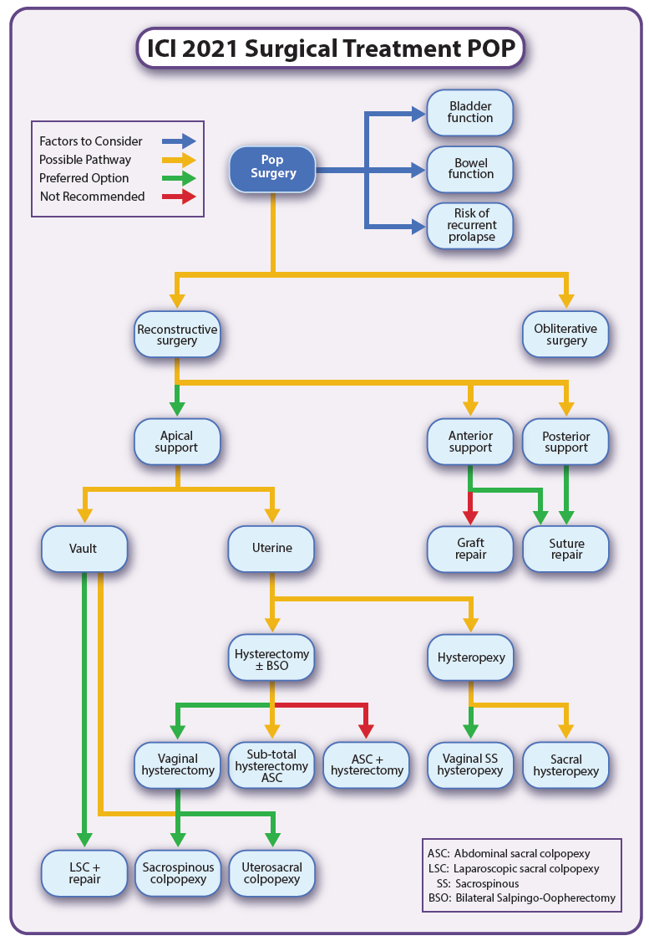

Christopher Maher

